# Thursday 3rd Dec 2020 (VD)

First ethane sample

12:13 T = 278.2 P = 5.65 * 10-9 mbar

12:15 Cryo turned on

13:56 T = 20.9 P = 7.2 10*-10 mbar

14:15 MCT Detector cooled

14:31 Laser turned on

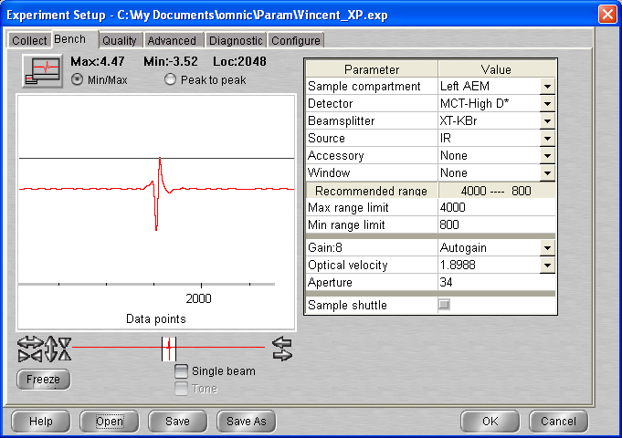

## Background scan(s) #1

**15:20 BG20201203_01**

512 scans 1 cm-1 res signal 4.55  
p = 7.1 x 10-10 mbar T = 20.7 K

**Ethane intro procédure :**

* Make sure that gas line has been pumped and purge the whole time (up to the regulator – all valves open)
* Close black valve and then leaking valve at top
* To make sure that no impurity : flush the line once :
  + Open bottle and then regulator and close again
  + Open black valve and close
  + Make sure that gas cell chamber valve closed and close pump valve
  + Open leak valve and fill gas line with ethane
  + Open pump valve and let time for the system to get flushed (close leak valve)
* Open ethane bottle and set regulator pressure slightly above 1 bar
* Open gas cell chamber valve and close valve pump
* Open ethane black valve and slightly open the leak valve to fill the gas cell chamber
* When desired pressure reached in gas cell chamber, close gas cell chamber black valve
* Close leak valve and black valve in gas inlet set up
* Close bottle and regulator
* Open pump valve
* Open black valve and leak valve to pump the ethane line
  + - * Carry on with the XP ☺ (If you haven’t blow up yet)

## Deposition #1: C2H6 @ 20.7 K

16:10 20 min @ 1x10-7 mbar C2H6

- Initial Temperature: 20.7 K

- Initial pressure: 6.5*10-10 mbar

- Initial gas cell pressure: (before introducing ethane reading = 0.059) – 0.796

- Deposition pressure: 1x10-7

- Laser signal: 251.4.9 mV

- Deposition time: 20 min

- pressure after deposition 1.3 * 10-9 mbar

- final gas cell pressure = 0.765 Torr

**16:31** laser Off / Head rotated

**16:34 C2H6_2020_12_03_0001**

512 scans 1 cm-1 res signal 4.29  
p = 8.5 x 10-10 mbar T = 20.7 K

**16:50 C2H6_2020_12_03_0002**

512 scans 1 cm-1 res signal 4.29  
p = 8.5 x 10-10 mbar T = 20.7 K

# 04/12

**12:30** P = 5 * 10 -10 T = 20.7

12:36 MCT Detector cooled

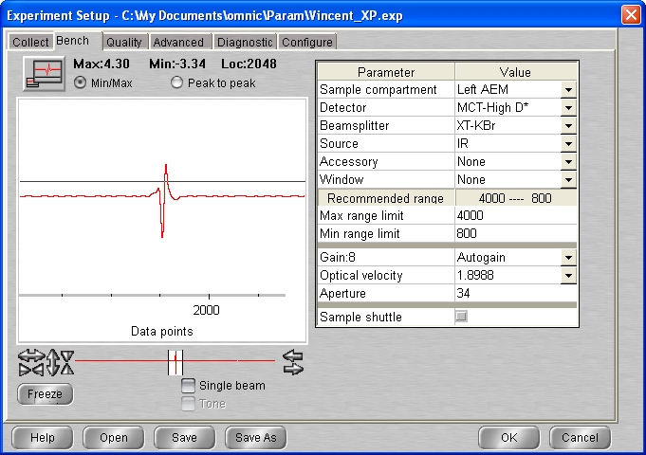

**13:18 C2H6_2020_12_03_0003**

512 scans 1 cm-1 res signal 4.30  
p = 5 x 10-10 mbar T = 20.7 K

**13:47 C2H6_2020_12_03_0004**

512 scans 1 cm-1 res signal 4.37  
p = 5 x 10-10 mbar T = 20.7 K

## Annealing to 30 K

**All files: C2H6_2020_12_03__000# (see tables)** 512 scans; 1 cm-1 res

|  |  |  |  |
| --- | --- | --- | --- |
| **time** | **File** | Type | signal |
| **14 :30** | **_0005** | Warm-up | 4.35 |
| **14 :45** | **_0006** | Iso1 | 4.35 |
| **15:00** | **_0007** | Iso2 |  |

## Annealing to 40 K

|  |  |  |  |
| --- | --- | --- | --- |
| **time** | **File** | Type | signal |
| **15 :15** | **_0008** | Warm-up |  |
| **15:30** | **_0009** | Iso1 | 4.34 |
| **15:45** | **_0010** | Iso2 | 4.33 |

## Annealing to 50 K

|  |  |  |  |
| --- | --- | --- | --- |
| **time** | **File** | Type | signal |
| **16 :00** | **_0011** | Warm-up | 4.34 |
| **16:15** | **_0012** | Iso1 | 4.32 |
| **16:30** | **_0013** | Iso2 | 4.33 |

## Annealing to 60 K

|  |  |  |  |
| --- | --- | --- | --- |
| **time** | **File** | Type | signal |
| **16 :45** | **_0014** | Warm-up |  |
| **17:00** | **_0015** | Iso1 |  |
| **17:15** | **_0016** | Iso2 | 4.32 |

## Annealing to 70 K

|  |  |  |  |
| --- | --- | --- | --- |
| **time** | **File** | Type | signal |
| **17 :30** | **_0017** | Warm-up | 4.31 |
| **17:45** | **_0018** | Iso1 |  |

18 :01 Heater turned off

18 :02 Cryo off

# 13/12 Shutting Down PAC

## 13:07 Turbo pump switched off

13:14 I close the leak valves on the gas lines (have been pumped and under vacuum)

13:16 T = 278.5 P Chamber = 4.2 * 10 -8 P gas cell = 0.059 Torr

13:20 P chamber = 1.8 * 10-7

13:23 P Chamber = 1.7 * 10-6

13:26 P chamber = 9.6 *10-6

13:27 P chamber= 2.4 * 10-5

## 13:25 N2 Filling procedure

13:25: Close gas chamber valve

13:30 N2 valve open (1.1 bar)

13:30 Open gas black valve and let some n2 leak (to let the air on the line get pumped)

Needle valve open and P set at 5 * 10-2

{…}

P = 1.2 mbar

All valved close

## 14:35 Switch off electronics

Heater

Baratron

Main chamber gage

Spectro

# Friday 29th Jan 2020 (VD)

First ethane sample

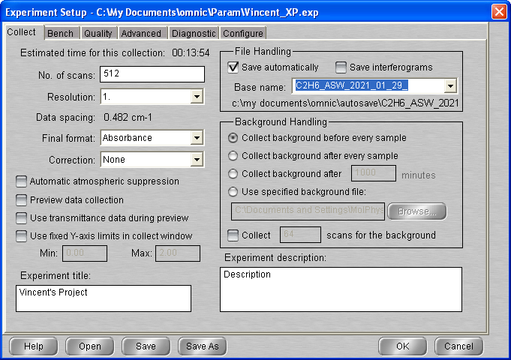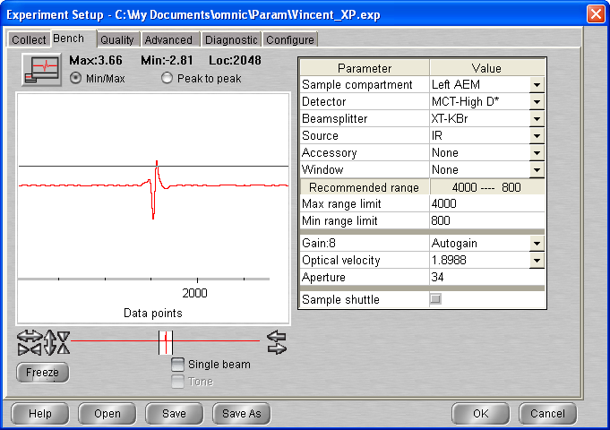

## Background scan(s) #1

**11:27 BG20210129_01**

512 scans 1 cm-1 res signal 3.88  
p = 1.3 x 10-9 mbar T = 20.8 K

## Mixture preparation : C2H6 - ASW 1:10 ratio

XX:XX - Initial gas cell pressure: 0.055

XX:XX - H2O intro (0.5) = 0.485

XX:XX -C2H6 intro ( + 0.5) = 1.034

XX:XX -Gas cell pump (down to 0.1) = 0.106 when valve closed but equilibrate at 0.986

XX:XX - H2O intro (up to 1) = 0.953

Remarque:

## Deposition #2: C2H6 - ASW @ 20.8 K

12:12 20 min @ 1x10-7 mbar C2H6 – ASW 1:10

- Initial Temperature: 20.8 K

- Initial pressure: 1.1*10-9 mbar

- Initial gas cell pressure: 0.953

- Deposition pressure: 1x10-7

- Laser signal: 251.9 mV

- Deposition time: 20 min

- pressure after deposition 1.2 * 10-8 mbar

- final gas cell pressure = 0.842 Torr

**12:34** laser Off / Head rotated

**12:38 C2H6_ASW_2021_01_29_0001**

512 scans 1 cm-1 res signal 3.83  
p = 5 x 10-9 mbar T = 20.8 K

**12:55 C2H6_ASW_2021_01_29_0002**

512 scans 1 cm-1 res signal 3.83  
p = 2.3 x 10-9 mbar T = 20.8 K

## Annealing to 30 K

**All files: C2H6_ASW_2021_01_29__000# (see tables)** 512 scans; 1 cm-1 res

|  |  |  |  |
| --- | --- | --- | --- |
| **time** | **File** | Type | signal |
| **13 :30** | **_0003** | Warm-up | 3.8 |
| **13 :45** | **_0004** | Iso1 | 3.79 |
| **14:00** | **_0005** | Iso2 | 3.79 |

## Annealing to 40 K

|  |  |  |  |
| --- | --- | --- | --- |
| **time** | **File** | Type | signal |
| **14:15** | **_0006** | Warm-up | 3.78 |
| **14 :30** | **_0007** | Iso1 | 3.77 |
| **14:45** | **_0008** | Iso2 |  |

## Annealing to 50 K

|  |  |  |  |
| --- | --- | --- | --- |
| **time** | **File** | Type | signal |
| **15 :00** | **_0009** | Warm-up | 3.77 |
| **15:15** | **_0010** | Iso1 | 3.77 |
| **15:30** | **_0011** | Iso2 |  |

## Annealing to 60 K

|  |  |  |  |
| --- | --- | --- | --- |
| **time** | **File** | Type | signal |
| **15 :45** | **_0012** | Warm-up | 3.76 |
| **16 :00** | **_0013** | Iso1 | 3.76 |

16 :15 Macro 20 scans (14 - 33)

# 30/01

**11:30** P = 5 * 10 -10 T = 60.1

11:42 MCT Detector cooled

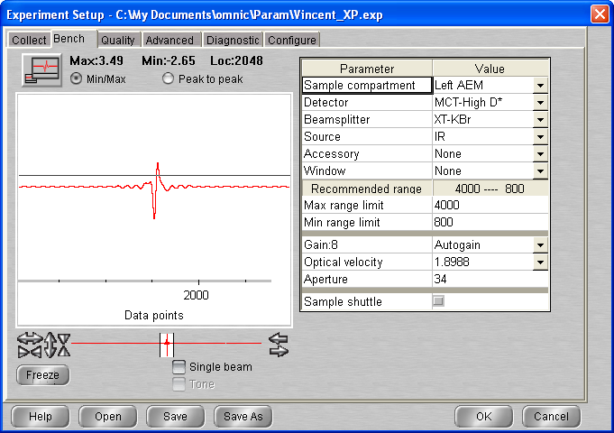

**12:00 C2H6_ASW_2021_01_29_0034**

512 scans 1 cm-1 res signal 3.66  
p = 5 x 10-10 mbar T = 60 K

**12:45 C2H6_ASW_2021_01_29_0035**

512 scans 1 cm-1 res signal 3.84  
p = 5 x 10-10 mbar T = 60 K

## Annealing to 70 K

|  |  |  |  |
| --- | --- | --- | --- |
| **time** | **File** | Type | signal |
| **13 :00** | **_0036** | Warm-up | 3.84 |
| **13:15** | **_0037** | Iso1 | 3.83 |
| **13:30** | **_0038** | Iso2 |  |

## Annealing to 80 K

|  |  |  |  |
| --- | --- | --- | --- |
| **time** | **File** | Type | signal |
| **13 :45** | **_0039** | Warm-up |  |
| **14:00** | **_0040** | Iso1 | 3.83 |
| **14:15** | **_0041** | Iso2 | 3.83 |

## Annealing to 90 K

|  |  |  |  |
| --- | --- | --- | --- |
| **time** | **File** | Type | signal |
| **14 :30** | **_0042** | Warm-up | 3.82 |
| **14:45** | **_0043** | Iso1 | 3.81 |
| **15:00** | **_0044** | Iso2 | 3.81 |

## Annealing to 100 K

|  |  |  |  |
| --- | --- | --- | --- |
| **time** | **File** | Type | signal |
| **15 :15** | **_0045** | Warm-up | 3.81 |
| **15:30** | **_0046** | Iso1 | 3.81 |
| **15:45** | **_0047** | Iso2 | 0.10 |

## Annealing to 110 K

|  |  |  |  |
| --- | --- | --- | --- |
| **time** | **File** | Type | signal |
| **16:00** | **_0048** | Warm-up | 3.79 |
| **16:15** | **_0049** | Iso1 | 3.79 |
| **16:30** | **_0050** | Iso2 |  |

## Annealing to 120 K

|  |  |  |  |
| --- | --- | --- | --- |
| **time** | **File** | Type | signal |
| **16:45** | **_0051** | Warm-up | 3.79 |
| **17:00** | **_0052** | Iso1 |  |
| **17:15** | **_0053** | Iso2 | 3.78 |

## Annealing to 130 K

|  |  |  |  |
| --- | --- | --- | --- |
| **time** | **File** | Type | signal |
| **17:30** | **_0054** | Warm-up | 3.79 |
| **17:45** | **_0055** | Iso1 | 3.79 |
| **18:00** | **_0056** | Iso2 |  |

## Annealing to 140 K

|  |  |  |  |
| --- | --- | --- | --- |
| **time** | **File** | Type | signal |
| **18:15** | **_0057** | Warm-up | 3.78 |
| **18:30** | **_0058** | Iso1 | 3.80 |
| **18:45** | **_0059** | Iso2 | 3.79 |

## Annealing to 150 K

|  |  |  |  |
| --- | --- | --- | --- |
| **time** | **File** | Type | signal |
| **19:00** | **_0060** | Warm-up | 3.78 |

# 19 : 15 Macro 30 scans

01/02 10 :30 cryo off / heater off

# Wednesday 24th Feb 2021 (VD) – water + ethane layer on top

13:58 T = 278.6 K P = 9.7 * 10-10

13:58 Cryo-on

14:00 Laser On

15:33 T = 20.8 P = 5* 10-10 mbar

15:55 MCT detector cooled

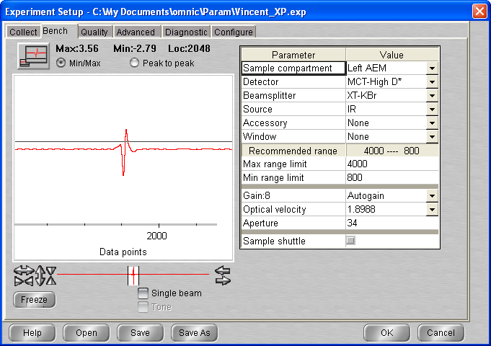

## Background scan(s) #1

**16:40 BG20210224_01**

512 scans res = 1 cm-1 signal = 3.71  
 p = 5 * 10-10 mbar T = 20.6K

17 :00 Head rotated (laser moved so put it back in place)

## Deposition #3.1: H2O @ 20K

11:40 10 min @ 1x10-7 mbar H2O

- Initial Temperature: 20.6K

- Initial pressure: 5 * 10-10 mbar

- Initial gas cell pressure: 7.35 Torr

- Deposition pressure: 1 * 10-7

- Laser signal: 322.4 mV

- Deposition time: 10 min

- pressure after deposition 9.3 e-9

- final gas cell pressure = 6.56 Torr

17 :18 Head rotated, laser off

**17:20 C2H6_ASW_2021_02_24_0001**

512 scans 1 cm-1 res signal 3.92  
p = 4 x 10-9 mbar T = 20.6 K

17 :35 Macro 40 scans

# 25/02

**10:07** P = 5 * 10 -10 T = 20.5

09:43 MCT Detector cooled – LASER on

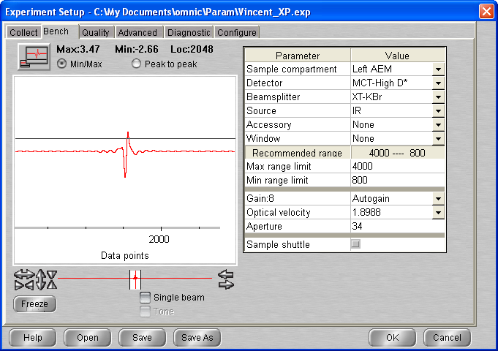

**10:15 C2H6_ASW_2021_02_24_0042**

512 scans 1 cm-1 res signal 3.90  
p = 5 x 10-10 mbar T = 20 K

**10:45 BG20210224_02**

512 scans res = 1 cm-1 signal = 3.99  
 p = 5 * 10-10 mbar T = 20.5K

## Deposition #3.2: C2H6 @ 20K

12:28 5 min @ 1x10-7 mbar C2H6

- Initial Temperature: 20.5K

- Initial pressure: 5 * 10-10 mbar

- Gas cell pressure empty: 0.055 (reading)

- Initial gas cell pressure: 7.86 Torr

- Deposition pressure: 1 * 10-7

- Laser signal: 324.8 mV

- Deposition time: 5 min

- pressure after deposition 1.3 * 10-9

- final gas cell pressure = 7.64Torr

12 :35 Head rotated, laser off

**12:38 C2H6_ASW_2021_02_24_0043 (bg1)**

512 scans 1 cm-1 res signal 3.75  
p = 5 x 10-10 mbar T = 20.5 K

(VERY FEW ETHANE – NO PRELIMINARY PUMPING OF GAS LINE)

**12:55 C2H6_ASW_2021_02_24_0044 (bg1)**

512 scans 1 cm-1 res signal 4.04  
p = 5 x 10-10 mbar T = 20 K

**13:12 C2H6_ASW_2021_02_24_0045 (bg2)**

512 scans 1 cm-1 res signal 4.04  
p = 5 x 10-10 mbar T = 20.4 K

**14:21 BG20210224_03**

512 scans res = 1 cm-1 signal = 4.02  
 p = 5 * 10-10 mbar T = 20.5K

14 :48 Laser On

## Deposition #3.3: C2H6 @ 20K

15:30 5 min @ 1x10-7 mbar C2H6

- Initial Temperature: 20.5K

- Initial pressure: 5 * 10-10 mbar

- Gas cell pressure empty: 0.056 (reading)

- Initial gas cell pressure: 8.70 Torr

- Deposition pressure: 1 * 10-7

- Laser signal: 325.5 mV

- Deposition time: 5 min

- pressure after deposition 5 * 10-10

- final gas cell pressure = 8.62Torr

15 :37 Head rotated

**15:40 C2H6_ASW_2021_02_24_0046 (bg1)**

512 scans 1 cm-1 res signal 4.04  
p = 5 x 10-10 mbar T = 20.5 K

**16:00 C2H6_ASW_2021_02_24_0047 (bg3)**

512 scans 1 cm-1 res signal 4.04  
p = 5 x 10-10 mbar T = 20.4 K

16 :15 Macro 20 scan (bkg 1 )

# 26/02

9:44 P = 5 * 10-10 T = 20.3

9:49 MCT Detector cooled

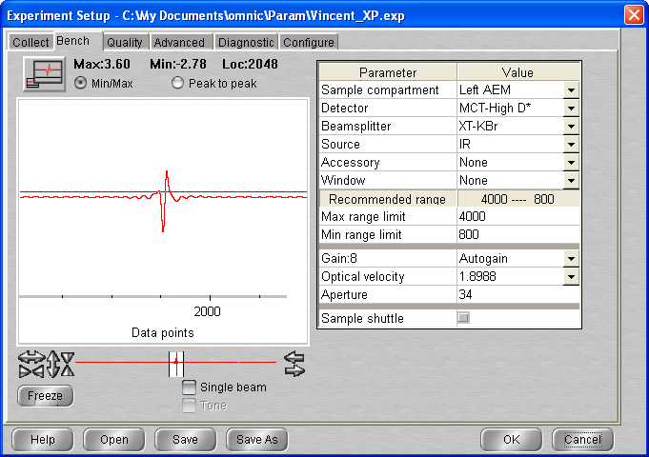

**10:45 C2H6_ASW_2021_02_24_0068 (bg1)**

512 scans 1 cm-1 res signal   
p = 5 x 10-10 mbar T = 20.4 K

**11:50 C2H6_ASW_2021_02_24_0069 (bg1)**

512 scans 1 cm-1 res signal 3.76  
p = 5 x 10-10 mbar T = 20.4 K

## Annealing to 30 K

512 scans; 1 cm-1 res

|  |  |  |  |
| --- | --- | --- | --- |
| **time** | **File** | Type | signal |
| **14 :00** | **_0070** | Warm-up | 3.68 |

+ Macro 7 scans

## Annealing to 40 K

512 scans; 1 cm-1 res

|  |  |  |  |
| --- | --- | --- | --- |
| **time** | **File** | Type | signal |
| **16 :00** | **_0078** | Warm-up | 3.66 |

16 :15 Macro 20 scans

# 27/02

9:47 P = 7.6 * 10-10 T = 40.0

10:00 MCT Detector cooled

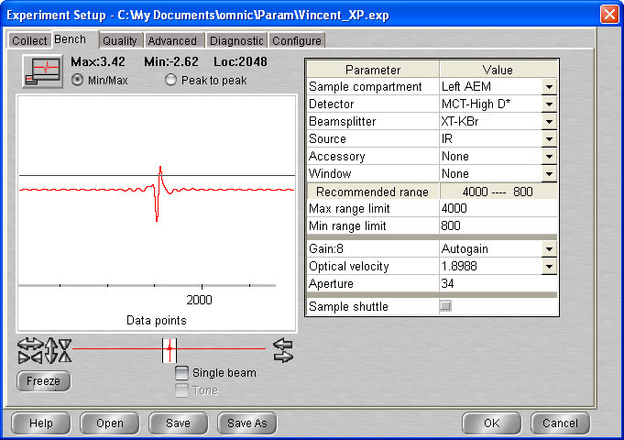

**10:30 C2H6_ASW_2021_02_24_0099 (bg1)**

512 scans 1 cm-1 res signal 3.71  
p = 7 x 10-10 mbar T = 40 K

**10:45 C2H6_ASW_2021_02_24_0100 (bg1)**

512 scans 1 cm-1 res signal 3.71  
p = 7 x 10-10 mbar T = 40 K

## Annealing to 50 K

512 scans; 1 cm-1 res

|  |  |  |  |
| --- | --- | --- | --- |
| **time** | **File** | Type | signal |
| **11 :00** | **_0101** | Warm-up | 3.73 |

+ Macro 7 scans

## Annealing to 60 K

512 scans; 1 cm-1 res

|  |  |  |  |
| --- | --- | --- | --- |
| **time** | **File** | Type | signal |
| **13 :00** | **_0109** | Warm-up | 3.68 |

+ Macro 7 scans

## Annealing to 70 K

512 scans; 1 cm-1 res

|  |  |  |  |
| --- | --- | --- | --- |
| **time** | **File** | Type | signal |
| **15 :00** | **_0117** | Warm-up | 3.64 |

+ Macro 7 scans

## Annealing to 80 K

512 scans; 1 cm-1 res

|  |  |  |  |
| --- | --- | --- | --- |
| **time** | **File** | Type | signal |
| **15 :00** | **_0125** | Warm-up | 3.60 |

+ Macro 20 scans

# 28/02

14:22 P = 5 * 10-10 T = 80.0

14:30 MCT Detector cooled

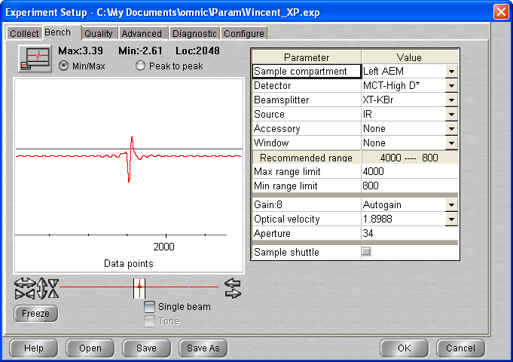

**14:45 C2H6_ASW_2021_02_24_0146 (bg1)**

512 scans 1 cm-1 res signal 3.49  
p = 7 x 10-10 mbar T = 80 K

15 :00 Macro 40 scans

# 01/03

**09:47** P = 5 * 10 -10 T = 80.0

09:53 MCT Detector cooled

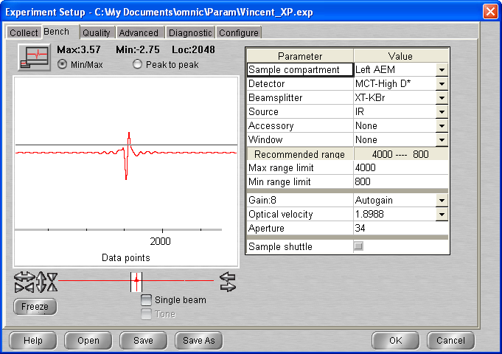

**10:25 C2H6_ASW_2021_02_24_0187 (bg1)**

512 scans 1 cm-1 res signal 3.64  
p = 5 x 10-10 mbar T = 80 K

**10:45 C2H6_ASW_2021_02_24_0188 (bg1)**

512 scans 1 cm-1 res signal 3.68  
p = 5 x 10-10 mbar T = 80 K

## Annealing to 90 K

512 scans; 1 cm-1 res

|  |  |  |  |
| --- | --- | --- | --- |
| **time** | **File** | Type | signal |
| **11 :00** | **_0189** | Warm-up | 3.67 |

+ Macro 7 scans

## Annealing to 100 K

512 scans; 1 cm-1 res

|  |  |  |  |
| --- | --- | --- | --- |
| **time** | **File** | Type | signal |
| **13 :00** | **_0197** | Warm-up | 3.63 |

+ Macro 7 scans

## Annealing to 110 K

512 scans; 1 cm-1 res

|  |  |  |  |
| --- | --- | --- | --- |
| **time** | **File** | Type | signal |
| **15 :00** | **_0205** | Warm-up | 3.60 |

+ Macro 7 scans

## Annealing to 120 K

512 scans; 1 cm-1 res

|  |  |  |  |
| --- | --- | --- | --- |
| **time** | **File** | Type | signal |
| **15 :00** | **_0213** | Warm-up | 3.60 |

+ Macro 20 scans

# 02/03

**09:50** P = 5 * 10 -10 T = 120.0

10:02 MCT Detector cooled

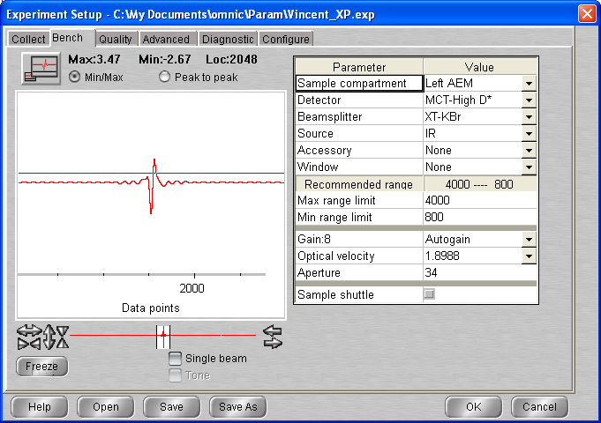

**10:30 C2H6_ASW_2021_02_24_0234 (bg1)**

512 scans 1 cm-1 res signal 3.51  
p = 5 x 10-10 mbar T = 120 K

**10:45 C2H6_ASW_2021_02_24_0235 (bg1)**

512 scans 1 cm-1 res signal 3.67  
p = 5 x 10-10 mbar T = 80 K

## Annealing to 130 K

512 scans; 1 cm-1 res

|  |  |  |  |
| --- | --- | --- | --- |
| **time** | **File** | Type | signal |
| **11 :00** | **_0236** | Warm-up | 3.68 |

+ Macro 60 scans

12 :21 P = 8.7 * 10-9

12 :32 P = 9.3 *10-9

# 03/03

**10:16** P = 3.8 * 10 -9 T = 130.0

10:27 MCT Detector cooled

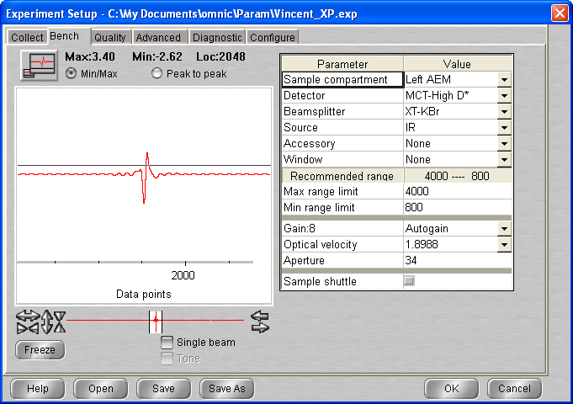

**10:50 C2H6_ASW_2021_02_24_0297 (bg1)**

512 scans 1 cm-1 res signal   
p = 3.8 x 10-9 mbar T = 130 K

**11:12 C2H6_ASW_2021_02_24_0298 (bg1)**

512 scans 1 cm-1 res signal   
p = 3.8 x 10-9 mbar T = 130 K

**11:58 C2H6_ASW_2021_02_24_0299 (bg1)**

512 scans 1 cm-1 res signal   
p = 3.8 x 10-9 mbar T = 130 K

**12:40 C2H6_ASW_2021_02_24_0300 (bg1)**

512 scans 1 cm-1 res signal 3.66  
p = 3.8 x 10-9 mbar T = 130 K

## Annealing to 135 K

512 scans; 1 cm-1 res

|  |  |  |  |
| --- | --- | --- | --- |
| **time** | **File** | Type | signal |
| **14 :00** | **_0301** | Warm-up | 3.63 |

+ Macro 7 scans

## Annealing to 140 K

512 scans; 1 cm-1 res

|  |  |  |  |
| --- | --- | --- | --- |
| **time** | **File** | Type | signal |
| **16 :00** | **_0309** | Warm-up | 3.61 |

+ Macro 40 scans

# 04/03

**11:13** P = 2.3 * 10 -8 T = 140.0

11:20 MCT Detector cooled

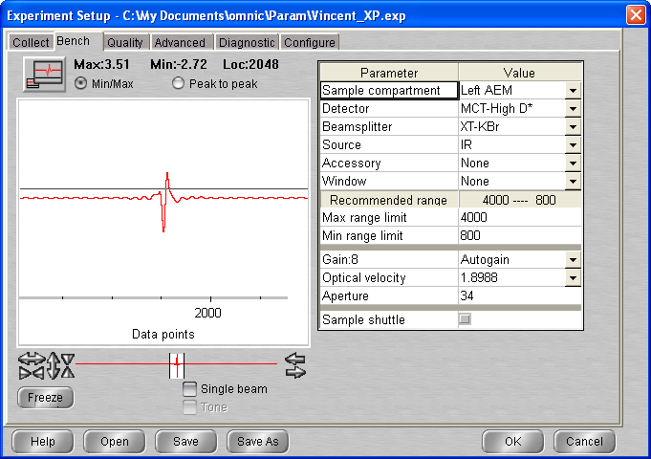

**12:25 C2H6_ASW_2021_02_24_0350 (bg1)**

512 scans 1 cm-1 res signal 3.64  
p = 2.3 x 10-8 mbar T = 140 K

## Annealing to 150 K

512 scans; 1 cm-1 res

|  |  |  |  |
| --- | --- | --- | --- |
| **time** | **File** | Type | signal |
| **13 :00** | **_0350** | Warm-up | 3.64 |

+ Macro 40 scans

05/03 14 :04 cryo stopped

# Wednesday 8th March 2021 (VD) – water + ethane Mixture 1:1

09:32 T = 278.4 K P = 1.1 * 10-9

09:32 Cryo-on

09:32 Laser On

10:06 T = 180.6 P = 8 * 10-10

10:16 MCT detector cooled

10:30 Initial gas cell pressure 0.077 🡪 warm up using heat gun (2 min P rise 0.080)

10:54 Pgas cell = 0.076

## Mixture preparation : C2H6 - ASW 1:1 ratio

10:58 - Initial gas cell pressure: 0.076

Procedure (LV = LEAK VALVE ; MV = MAIN VALVE)

* Water intro:
  + Close ethane line LV (P gas cell chamber decrease – leak ?)
  + P gas cell chamber stabilise at 0.055 ☺
  + Close water line (LV)
  + Close gas cell chamber
  + Open water MV
  + Close valve Pump
  + Open gas cell valve
  + Open water LV slowly up to desire value

XX:XX - H2O intro (0.5) = 0.516

* + Let the pressure equilibrate and close the gas cell chamber valve
  + Close water MV
  + Open water LV
  + Open pump valve and allow time for the system to pump
  + Open ethane LV (All open up to bottle)
  + Close regulator MV AND Lv IN THAT ORDER
  + Close pump valve
  + Open ethane bottle and regulator up to 1.1 bar, MV and LV (briefly LV and close)
  + Open pump valve (flush) and close
  + Open ethane LV and glas cell chamber valve (together and close gas cell chamber valve when ethane intro done (real quick))

XX:XX -C2H6 intro ( + 0.5) = 1.077

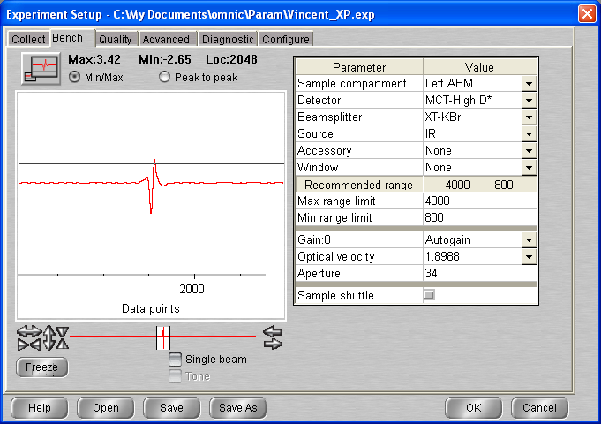

## Background scan(s) #1

**11:35 BG20210308_01**

512 scans res = 1 cm-1 signal = 3.51  
 p = 5 * 10-10 mbar T = 20.6K

## Deposition #4: C2H6 - ASW @ 20.5 K

12:05 20 min @ 1x10-7 mbar C2H6 – ASW 1:1

- Initial Temperature: 20.5 K

- Initial pressure: 5*10-10 mbar

- Initial gas cell pressure: 1.062

- Deposition pressure: 1x10-7

- Laser signal: 327.0 mV

- Deposition time: 20 min

- pressure after deposition 6 * 10-9 mbar

- final gas cell pressure = 1.008 Torr

**12:30** laser Off / Head rotated

**12:30 C2H6_ASW_2021_03_08_0001 (bg1)**

512 scans 1 cm-1 res signal 3.94  
p = 3 x 10-9 mbar T = 20.5 K

**13:06 C2H6_ASW_2021_03_08_0002 (bg1)**

512 scans 1 cm-1 res signal 3.92  
p = 9 x 10-10 mbar T = 20.5 K

**13:30 C2H6_ASW_2021_03_08_0003 (bg1)**

512 scans 1 cm-1 res signal 3.91  
p = 7.5 x 10-10 mbar T = 20.5 K

**13:45 C2H6_ASW_2021_03_08_0004 (bg1)**

512 scans 1 cm-1 res signal 3.91  
p = 7.5 x 10-10 mbar T = 20.5 K

14 :00 MACRO 40 scans

09/03/

P = 5 * 10-10 T = 20.4

09 :50 MCT Detctor cooled

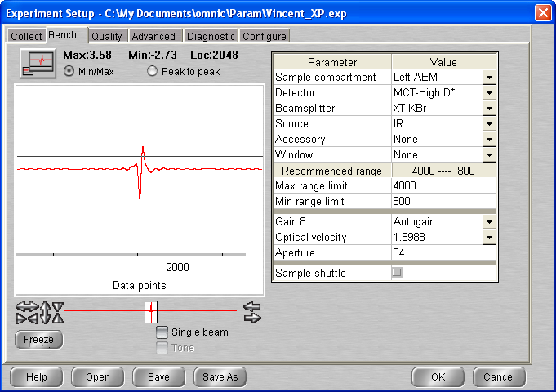

**10:00 C2H6_ASW_2021_03_08_0045**

512 scans 1 cm-1 res signal 3.76  
p = 5 x 10-10 mbar T = 20.4 K

**10:30 C2H6_ASW_2021_03_08_0046**

512 scans 1 cm-1 res signal 4.00  
p = 5 x 10-10 mbar T = 20.4 K

**11:00 C2H6_ASW_2021_03_08_0047**

512 scans 1 cm-1 res signal   
p = 5 x 10-10 mbar T = 20.4 K

**11:30 C2H6_ASW_2021_03_08_0048**

512 scans 1 cm-1 res signal 4.01  
p = 5 x 10-10 mbar T = 20.4 K

12 :00 Macro 10 scans

**14:30 C2H6_ASW_2021_03_08_0059**

512 scans 1 cm-1 res signal 3.96  
p = 5 x 10-10 mbar T = 20.3 K

**14:45 C2H6_ASW_2021_03_08_0060**

512 scans 1 cm-1 res signal 3.95  
p = 5 x 10-10 mbar T = 20.3 K

15 :00 MACRO 16 SCANS

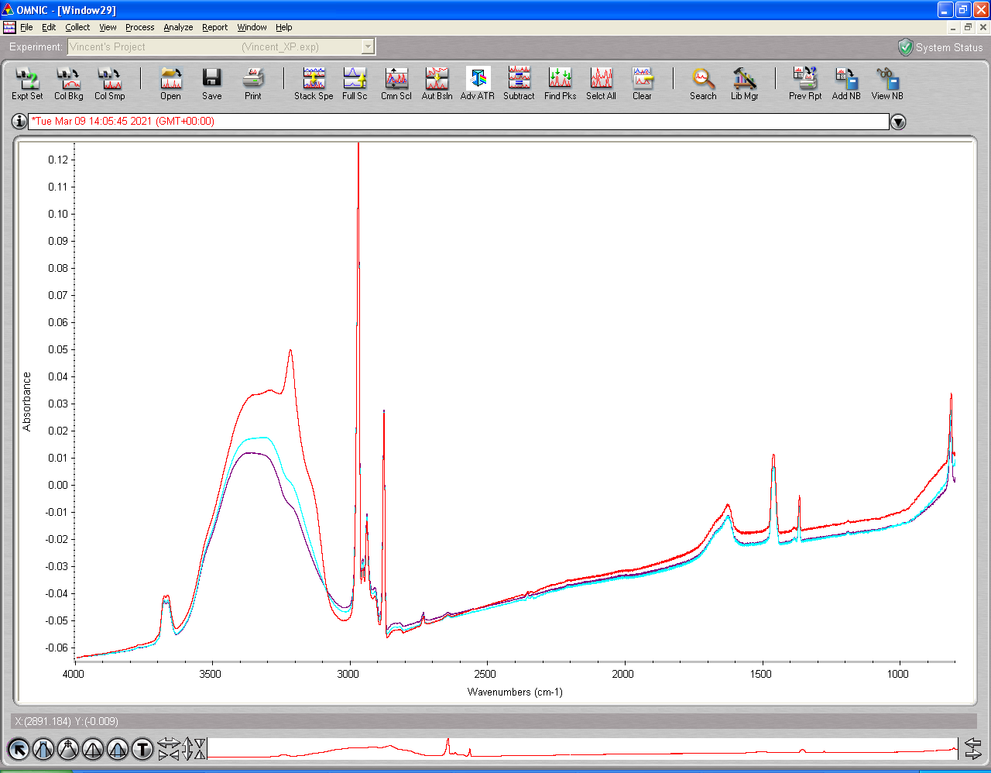

18 :45 Macro 40 scans

10/03

10 :16 MCT Detector cooled T = 20.3 P = 5 * 10-10

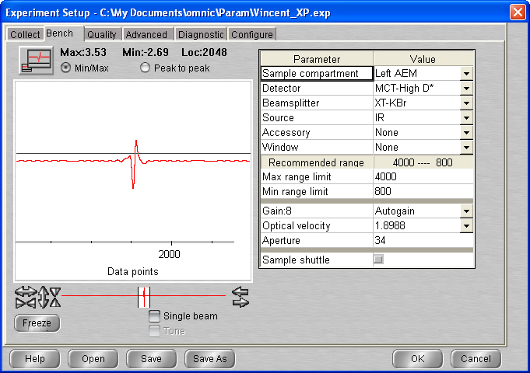

**10:30 C2H6_ASW_2021_03_08_0117 (bg1)**

512 scans 1 cm-1 res signal   
p = 5 x 10-10 mbar T = 20.3 K

**10:45 C2H6_ASW_2021_03_08_0118 (bg1)**

512 scans 1 cm-1 res signal 4.00  
p = 5 x 10-10 mbar T = 20.3 K

## Annealing to 30 K

512 scans; 1 cm-1 res

|  |  |  |  |
| --- | --- | --- | --- |
| **time** | **File** | Type | signal |
| **11 :00** | **_0119** | Warm-up | 4.03 |

+ Macro 7 scans

## Annealing to 40 K

512 scans; 1 cm-1 res

|  |  |  |  |
| --- | --- | --- | --- |
| **time** | **File** | Type | signal |
| **13 :00** | **_0127** | Warm-up | 4.03 |

+ Macro 7 scans

## Annealing to 50 K

512 scans; 1 cm-1 res

|  |  |  |  |
| --- | --- | --- | --- |
| **time** | **File** | Type | signal |
| **15 :00** | **_0136** | Warm-up |  |

+ Macro 7 scans

17 :00 Macro 4 scan

18 :00 Macro 4 scan

## Annealing to 60 K

512 scans; 1 cm-1 res

|  |  |  |  |
| --- | --- | --- | --- |
| **time** | **File** | Type | signal |
| **19 :00** | **_0151** | Warm-up |  |

+ Macro 7 scans

21 :02 MCT Detector cooled

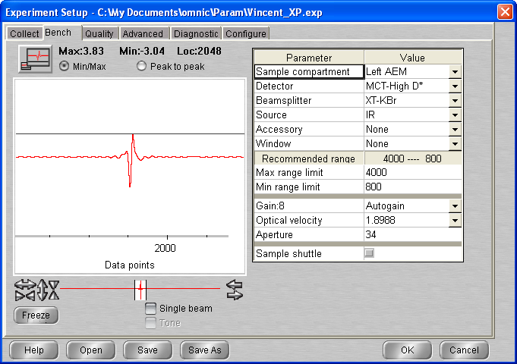

**21:30 C2H6_ASW_2021_03_08_0159 (bg1)**

512 scans 1 cm-1 res signal 3.83  
p = 3.1 x 10-8 mbar T = 60 K

21 :45 Macro 80 (exit at loop 60 up to scan )

11/03

11 :49 MCT Detector cooled

12:56

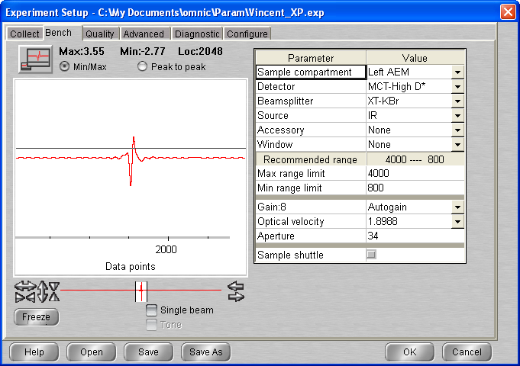

**13:00 C2H6_ASW_2021_03_08_0220 (bg1)**

512 scans 1 cm-1 res signal 3.74  
p = 2 x 10-8 mbar T = 60 K

**13:30 C2H6_ASW_2021_03_08_0221 (bg1)**

512 scans 1 cm-1 res signal   
p = 2 x 10-8 mbar T = 60 K

## Annealing to 70 K

512 scans; 1 cm-1 res

|  |  |  |  |
| --- | --- | --- | --- |
| **time** | **File** | Type | signal |
| **14 :00** | **_0222** | Warm-up | 3.77 |

+ Macro 7 scans

## Annealing to 80 K

512 scans; 1 cm-1 res

|  |  |  |  |
| --- | --- | --- | --- |
| **time** | **File** | Type | signal |
| **16 :00** | **_0230** | Warm-up | 3.62 |

+ Macro 7 scans

## Annealing to 90 K

512 scans; 1 cm-1 res

|  |  |  |  |
| --- | --- | --- | --- |
| **time** | **File** | Type | signal |
| **18 :00** | **_0238** | Warm-up | 3.60 |

+ Macro 20 scans

12/03

09 :42 P = 5 * 10-10 T = 90K

09 :49 MCT Detector cooled

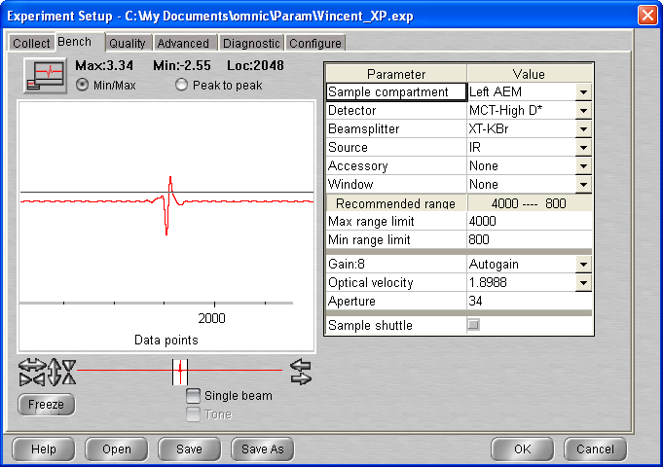

**10:15 C2H6_ASW_2021_03_08_0259 (bg1)**

512 scans 1 cm-1 res signal   
p = 2 x 10-8 mbar T = 90 K

**10:30 C2H6_ASW_2021_03_08_0260 (bg1)**

512 scans 1 cm-1 res signal 3.70  
p = 2 x 10-8 mbar T = 90 K

## Annealing to 100 K

512 scans; 1 cm-1 res

|  |  |  |  |
| --- | --- | --- | --- |
| **time** | **File** | Type | signal |
| **11 :00** | **_0261** | Warm-up | 3.71 |

+ Macro 7 scans

## Annealing to 110 K

512 scans; 1 cm-1 res

|  |  |  |  |
| --- | --- | --- | --- |
| **time** | **File** | Type | signal |
| **13 :00** | **_0269** | Warm-up |  |

+ Macro 7 scans

## Annealing to 120 K

512 scans; 1 cm-1 res

|  |  |  |  |
| --- | --- | --- | --- |
| **time** | **File** | Type | signal |
| **15 :00** | **_0277** | Warm-up | 3.67 |

+ Macro 7 scans

## Annealing to 130 K

512 scans; 1 cm-1 res

|  |  |  |  |
| --- | --- | --- | --- |
| **time** | **File** | Type | signal |
| **17 :00** | **_0285** | Warm-up | 3.65 |

+ Macro 20 scans

13/03

12 :26 T = 130.0 P = 4.6 e-9

12 :35 MCT Detector cooled (and realigned)

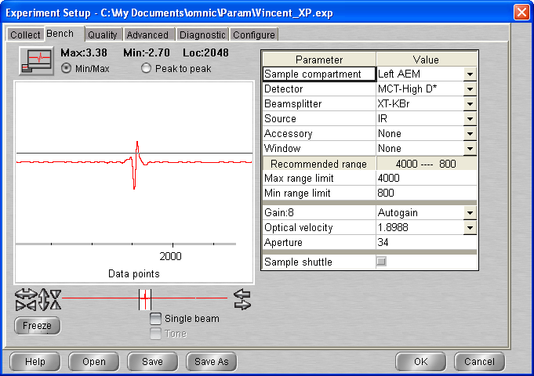

**13:00 C2H6_ASW_2021_03_08_0306 (bg1)**

512 scans 1 cm-1 res signal 3.70  
p = 4.6 x 10-9 mbar T = 130 K

**15:45 C2H6_ASW_2021_03_08_0307 (bg1)**

512 scans 1 cm-1 res signal 3.30  
p = 4.5 x 10-9 mbar T = 130 K

15/03/2021

13 :10 P = 4 * 10-9 T = 130K

13 :20 MCT Detector cooled

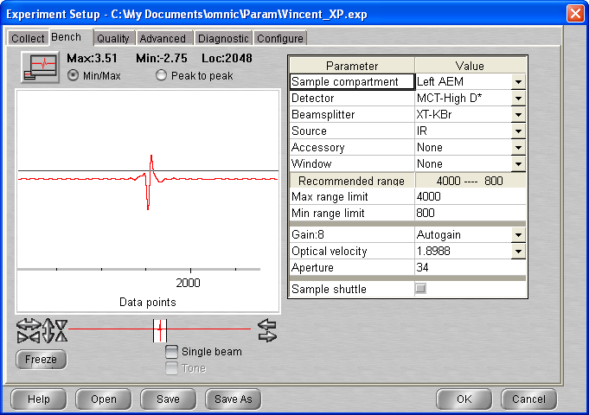

**13:45 C2H6_ASW_2021_03_08_0308 (bg1)**

512 scans 1 cm-1 res signal   
p = 3.6 x 10-9 mbar T = 130 K

**14:00 C2H6_ASW_2021_03_08_0309 (bg1)**

512 scans 1 cm-1 res signal   
p = 3.6 x 10-9 mbar T = 130 K

**14:30 C2H6_ASW_2021_03_08_0310 (bg1)**

512 scans 1 cm-1 res signal 3.58  
p = 3.3 x 10-9 mbar T = 130 K

**14:45 C2H6_ASW_2021_03_08_0311 (bg1)**

512 scans 1 cm-1 res signal 3.58  
p = 3.3 x 10-9 mbar T = 130 K

Macro 4 scans

(15 :15 air pressure set up to 75 psi)

## Annealing to 140 K

512 scans; 1 cm-1 res

|  |  |  |  |
| --- | --- | --- | --- |
| **time** | **File** | Type | signal |
| **16 :00** | **_0316** | Warm-up | 3.58 |

+ Macro 7 scans

## Annealing to 150 K

512 scans; 1 cm-1 res

|  |  |  |  |
| --- | --- | --- | --- |
| **time** | **File** | Type | signal |
| **18 :00** | **_0324** | Warm-up | 3.59 |

+ Macro 20 scans

# Wednesday 24th March 2021 (VD) – water + ethane Mixture 1:1 (II)

14:15 Cryo-on

15:25 Laser On

15:25 T = 20.8 P = 5 * 10-10

15:30 MCT detector cooled

16:26 P = 5 e-10 T = 20.4K

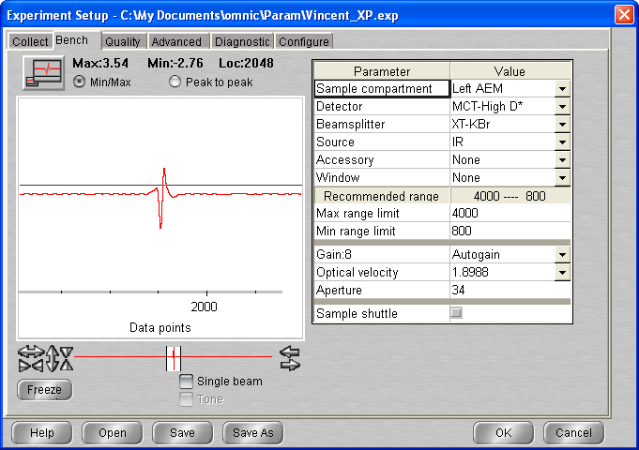

## Background scan(s) #1

**11:35 BG20210324_01**

512 scans res = 1 cm-1 signal = 3.55  
 p = 5 * 10-10 mbar T = 20.4K

## Deposition #4: C2H6 - ASW @ 20.5 K

17:15 20 min @ 1x10-7 mbar C2H6 – ASW 1:1

- Initial Temperature: 20.4 K

- Initial pressure: 5*10-10 mbar

- Initial gas cell pressure: 0.993

- Deposition pressure: 1x10-7

- Laser signal: 311.2 mV

- Deposition time: 20 min

- final gas cell pressure = 0.944 Torr

**17:32** laser Off / Head rotated

**17:34 C2H6_ASW_2021_03_24_0001 (bg1)**

512 scans 1 cm-1 res signal 3.94  
p = 3 x 10-9 mbar T = 20.5 K

Macro 80 – exit at loop 73

25/03/2021

10 :37 T = 20.3K P = 5 * 10e-10

10 :47 MCT Detector cooled

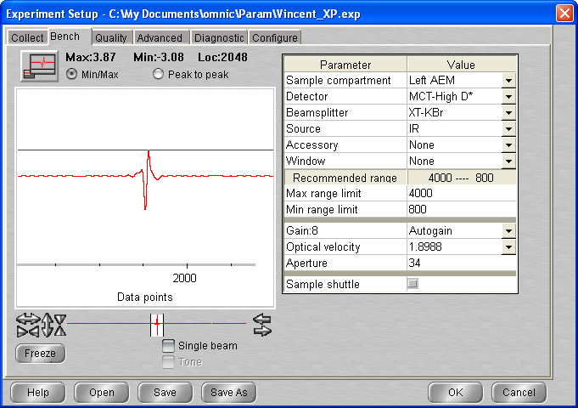

**11:00 C2H6_ASW_2021_03_24_0074 (bg1)**

512 scans 1 cm-1 res signal 3.88  
p = 5 x 10-10 mbar T = 20.2 K

**11:22 C2H6_ASW_2021_03_24_0075 (bg1)**

512 scans 1 cm-1 res signal   
p = 5 x 10-10 mbar T = 20.2 K

**11:40 C2H6_ASW_2021_03_24_0076 (bg1)**

512 scans 1 cm-1 res signal 3.92  
p = 5 x 10-10 mbar T = 20.2 K

12 :00 Macro 20 (up to scan 96)

**16:45 C2H6_ASW_2021_03_24_0097 (bg1)**

512 scans 1 cm-1 res signal 3.89  
p = 5 x 10-10 mbar T = 20.2 K

17 :00 Macro 40

26/03/2021

11 :07 MCT Detector cooled

12 :54 T = 20.2 P = 5 *10-10

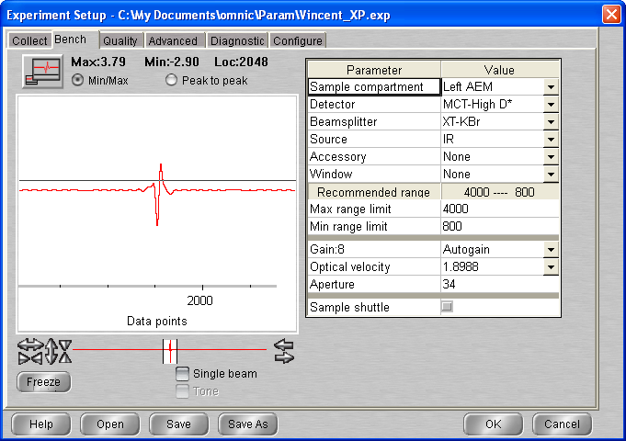

**13:00 C2H6_ASW_2021_03_24_0138 (bg1)**

512 scans 1 cm-1 res signal 3.80  
p = 5 x 10-10 mbar T = 20.2 K

**13:18 C2H6_ASW_2021_03_24_0139 (bg1)**

512 scans 1 cm-1 res signal 3.97  
p = 5 x 10-10 mbar T = 20.2 K

## Annealing to 130 K

512 scans; 1 cm-1 res

|  |  |  |  |
| --- | --- | --- | --- |
| **time** | **File** | Type | signal |
| **14 :00** | **_0140** | Warm-up | 3.97 |

**14:18 C2H6_ASW_2021_03_24_0141 (bg1)**

512 scans 1 cm-1 res signal 3.67  
p = 3.3 x 10-8 mbar T = 129 K

**14:34 C2H6_ASW_2021_03_24_0142 (bg1)**

512 scans 1 cm-1 res signal 3.67  
p = 1.1 x 10-8 mbar T = 129.9 K

**14:49 C2H6_ASW_2021_03_24_0143 (bg1)**

512 scans 1 cm-1 res signal 3.67  
p = 8 x 10-9 mbar T = 129.9 K

15 :05

+ Macro 40 scans

27/03/2021

10 :44 T = 130k P = 4.6 *10e-9

10:55 MCT Detector cooled

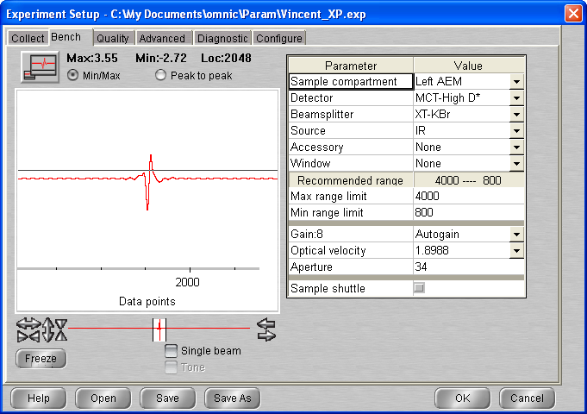

**11:20 C2H6_ASW_2021_03_24_0184 (bg1)**

512 scans 1 cm-1 res signal 3.59  
p = 4.5 x 10-9 mbar T = 130 K

**11:35 C2H6_ASW_2021_03_24_0185 (bg1)**

512 scans 1 cm-1 res signal 3.61  
p = 4.5 x 10-9 mbar T = 130 K

**11:50 C2H6_ASW_2021_03_24_0186 (bg1)**

512 scans 1 cm-1 res signal 3.61  
p = 4.5 x 10-9 mbar T = 130 K

+ Macro 4 scans (up to 190)

## Annealing to 135 K

512 scans; 1 cm-1 res

|  |  |  |  |
| --- | --- | --- | --- |
| **time** | **File** | Type | signal |
| **13:00** | **_0191** | Warm-up | 3.58 |

+ Macro 3 scan

## Annealing to 140 K

512 scans; 1 cm-1 res

|  |  |  |  |
| --- | --- | --- | --- |
| **time** | **File** | Type | signal |
| **14:00** | **_0195** | Warm-up | 3.57 |

+ Macro 3 scan

## Annealing to 150 K

512 scans; 1 cm-1 res

|  |  |  |  |
| --- | --- | --- | --- |
| **time** | **File** | Type | signal |
| **15:00** | **_0199** | Warm-up | 3.55 |

+ Macro 20 scan (exit loop 9)

17 :30 Cryo off Heater off

# Friday 16th July 2021 (VD) – water + ethane 1:1 ratio

11:00 Cryo-on

11:00 Laser On

15:21 T = 19.9 K P = 1.1* 10-9 mbar

14:45 MCT detector cooled

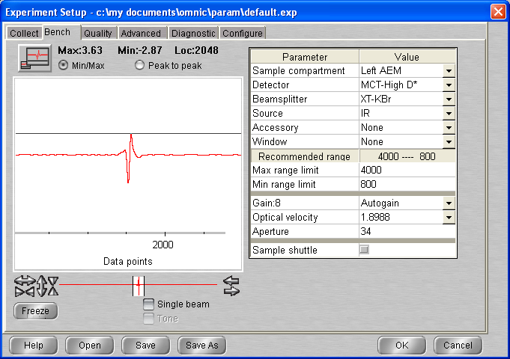

## Background scan(s) #1

**15:35 BG20210716_01**

512 scans res = 1 cm-1 signal = 3.67  
 p = 1.1 * 10-9 mbar T = 19.9K

## Deposition #: C2H6 – ASW 1:1 @ 20.5 K

16:00 20 min @ 1x10-7 mbar C2H6 – ASW 1:1

- Initial Temperature: 19.9 K

- Initial pressure: 1*05 * -9 mbar

- Initial gas cell pressure: 1.067

- Deposition pressure: 1x10-7

- Laser signal: 327 mV

- Deposition time: 20 min

- final gas cell pressure = 1.018 Torr

**16:20** laser Off / Head rotated

**16:22 C2H6_ASW_2021_07_16_0001 (bg1)**

512 scans 1 cm-1 res signal 4.11  
p =5 x 10-9 mbar T = 19.9 K

16 :40 Macro 60 scans up to scan 61

17/07 13 :13 MCT Detector cooled

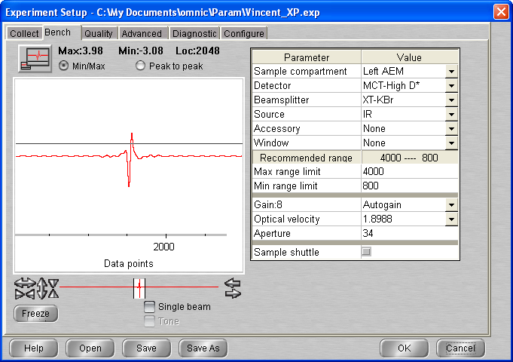

**13:25 C2H6_ASW_2021_07_16_0062 (bg1)**

512 scans 1 cm-1 res signal 4.02  
p =7 x 10-10 mbar T = 19.9 K

**13:40 C2H6_ASW_2021_07_16_0063 (bg1)**

512 scans 1 cm-1 res signal 4.11  
p =7 x 10-10 mbar T = 19.9 K

14 :00 Macro 40 up to scan 103

18/07/2021

15 :40 MCT Detector cooled

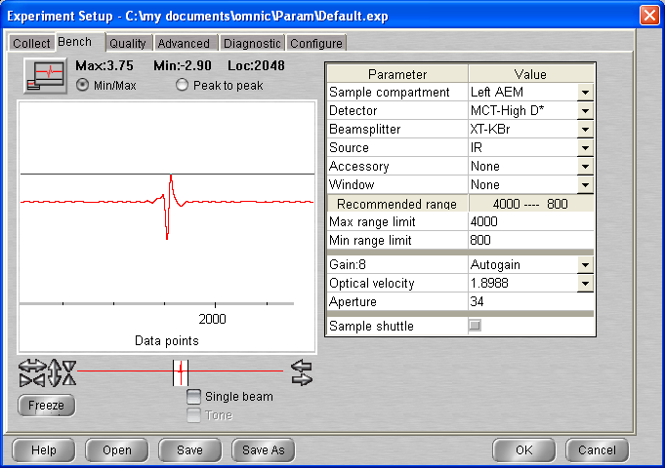

**16:00 C2H6_ASW_2021_07_16_0104 (bg1)**

512 scans 1 cm-1 res signal 4.02  
p =5.7 x 10-10 mbar T = 19.8 K

16 :15 Macro 60 scans up to scan 164

19/07/2021

10 :43 MCT Detector cooled`

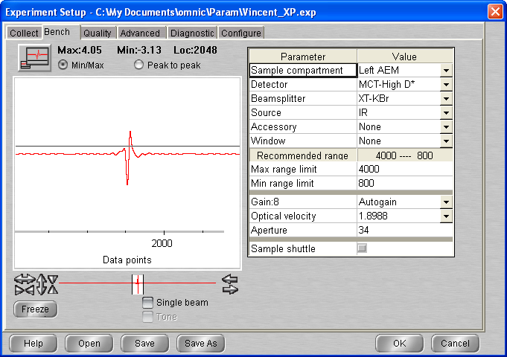

**11:15 C2H6_ASW_2021_07_16_0165 (bg1)**

512 scans 1 cm-1 res signal 4.11  
p =5 x 10-10 mbar T = 19.6 K

**11:30 C2H6_ASW_2021_07_16_0166 (bg1)**

512 scans 1 cm-1 res signal 4.21  
p =5 x 10-10 mbar T = 19.6 K

**11:45 C2H6_ASW_2021_07_16_0167 (bg1)**

512 scans 1 cm-1 res signal 4.22  
p =5 x 10-10 mbar T = 19.6 K

12 :00 Macro 60 scans EXIT AT LOOP 30 up to scan 197

19:04 MCT Detector cooled

**19:15 C2H6_ASW_2021_07_16_0198 (bg1)**

512 scans 1 cm-1 res signal 4.07  
p =5 x 10-10 mbar T = 19.6 K

19 :30 Macro 70 scans exit at loop 63 (10 :05) up to scan 261

20/07

10:30 MCT Detector cooled

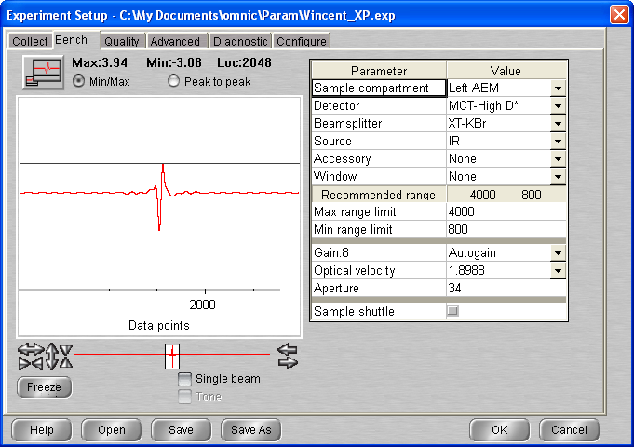

**10:45 C2H6_ASW_2021_07_16_0262 (bg1)**

512 scans 1 cm-1 res signal 3.93  
p =5 x 10-10 mbar T = 19.6 K

11 :00 Macro 60 scans up to scan 322

21/07/2021

16 :40 MCT Detector cooled

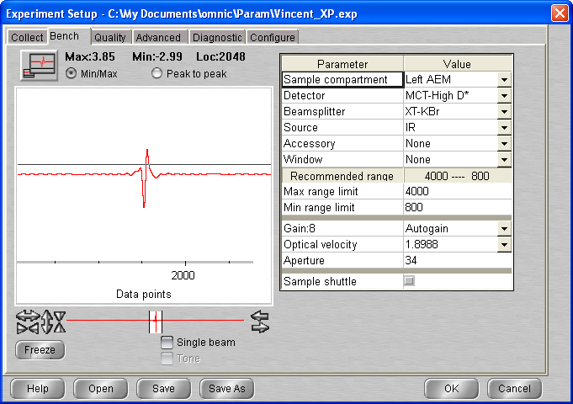

**17:00 C2H6_ASW_2021_07_16_0323 (bg1)**

512 scans 1 cm-1 res signal 3.96  
p =5 x 10-10 mbar T = 19.6 K

17 :15 Macro 7 scan up to scan 330

## Annealing to 60 K

512 scans; 1 cm-1 res

|  |  |  |  |
| --- | --- | --- | --- |
| **time** | **File** | Type | signal |
| **19 :00** | **_0331** | Warm-up | 4.13 |

+ Macro 60 scans up to scan 391

22/07/2021

14:10 MCT Detector cooled

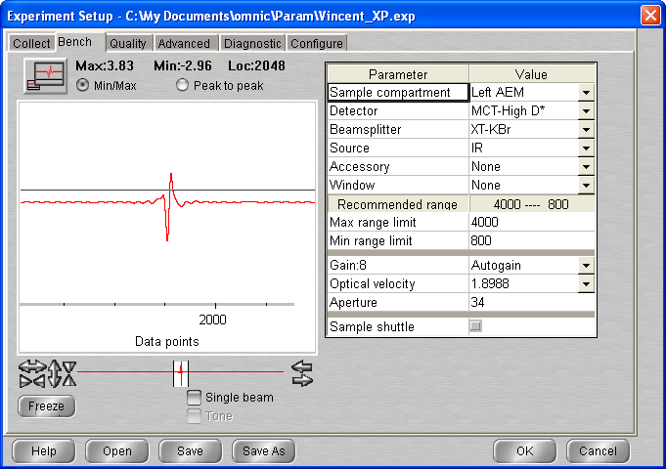

**14:30 C2H6_ASW_2021_07_16_0392 (bg1)**

512 scans 1 cm-1 res signal 3.88  
p =2.3 x 10-8 mbar T = 60 K

**14:45 C2H6_ASW_2021_07_16_0393 (bg1)**

512 scans 1 cm-1 res signal 4.11  
p =2.1 x 10-8 mbar T = 60 K

15 :00 Macro 60 scans up to scan 453

23/07/2021

11 :05 P = 5.8 * 10-9 T = 60K

11 :15 MCT Detector cooled

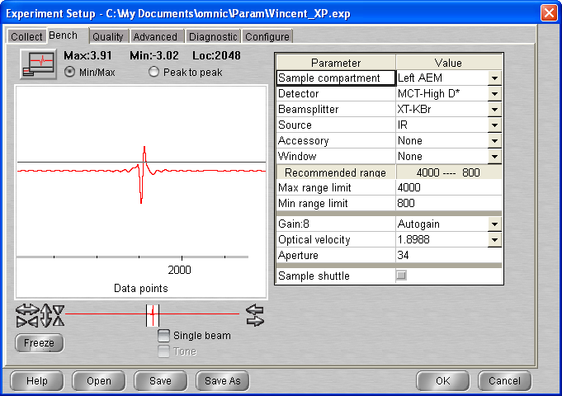

**11:30 C2H6_ASW_2021_07_16_0454 (bg1)**

512 scans 1 cm-1 res signal 3.98  
p =5.6 x 10-9 mbar T = 60 K

**11:45 C2H6_ASW_2021_07_16_0455 (bg1)**

512 scans 1 cm-1 res signal 3.98  
p =5.6 x 10-9 mbar T = 60 K

12 :00 Macro 60 scans up to scan 515

24/07/2021

13 :10 P = 2.4 * 10-9 T = 60K

13 :12 MCT Detector cooled

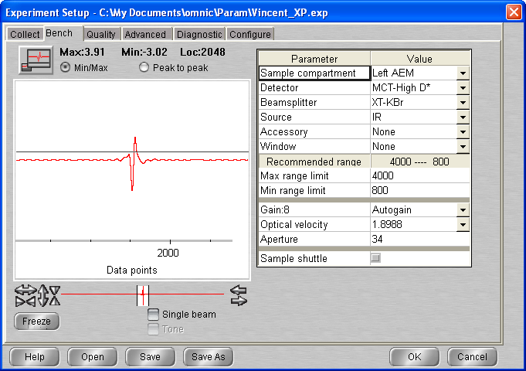

**13:30 C2H6_ASW_2021_07_16_0516 (bg1)**

512 scans 1 cm-1 res signal 3.93  
p =2.4 x 10-9 mbar T = 60 K

**13:45 C2H6_ASW_2021_07_16_0517 (bg1)**

512 scans 1 cm-1 res signal 3.98  
p =2.4 x 10-9 mbar T = 60 K

14 :00 Macro 30 scans exit at loop 17 up to scan 534

## Annealing to 70 K

512 scans; 1 cm-1 res

|  |  |  |  |
| --- | --- | --- | --- |
| **time** | **File** | Type | signal |
| **18 :00** | **_0535** | Warm-up | 3.89 |

**18:15 C2H6_ASW_2021_07_16_0536 (bg1)**

512 scans 1 cm-1 res signal 3.86  
p =3. x 10-7 mbar T = 69.8 K

**19:00 C2H6_ASW_2021_07_16_0537 (bg1)**

512 scans 1 cm-1 res signal 3.84  
p =7.1 x 10-8 mbar T = 69.9 K

**19:15 C2H6_ASW_2021_07_16_0538 (bg1)**

512 scans 1 cm-1 res signal 3.83  
p =5.8 x 10-8 mbar T = 70.0 K

**19:30 C2H6_ASW_2021_07_16_0539 (bg1)**

512 scans 1 cm-1 res signal 3.83  
p =4.2 x 10-8 mbar T = 70.0 K

## Annealing to 135 K

512 scans; 1 cm-1 res

|  |  |  |  |
| --- | --- | --- | --- |
| **time** | **File** | Type | signal |
| **19 :45** | **_0540** | Warm-up | 3.83 |

**20:00 C2H6_ASW_2021_07_16_0541 (bg1)**

512 scans 1 cm-1 res signal 3.83  
p =1.5 x 10-7 mbar T = 133.4 K

**20:15 C2H6_ASW_2021_07_16_0542 (bg1)**

512 scans 1 cm-1 res signal 3.83  
p =5.6 x 10-8 mbar T = 135K

20 :32 MCT Detector cooled

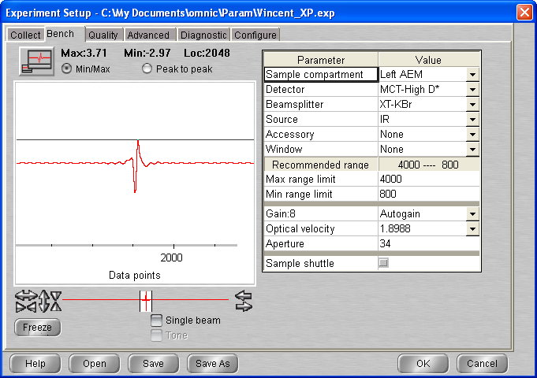

**20:45 C2H6_ASW_2021_07_16_0543 (bg1)**

512 scans 1 cm-1 res signal 3.70  
p =3.5 x 10-8 mbar T = 135K

21 :00 Macro 80 scans exit at loop 65 up to scan 608

25/07/2021

12:12 MCT Detector cooled

**12:30 C2H6_ASW_2021_07_16_0609 (bg1)**

512 scans 1 cm-1 res signal 3.70  
p =1.5 x 10-8 mbar T = 135K

**12:45 C2H6_ASW_2021_07_16_0610 (bg1)**

512 scans 1 cm-1 res signal 3.70  
p =1.4 x 10-8 mbar T = 135K

13 :00 Macro 80 scans exit at loop 23 up to scan 633

18:26 MCT Detector cooled

**18:45 C2H6_ASW_2021_07_16_0634 (bg1)**

512 scans 1 cm-1 res signal 3.66  
p =7.6 x 10-9 mbar T = 135K

19 :00 Macro 80 scans exit at loop 67 up to scan 701

26/07/2021

10:39 MCT Detector cooled

**11:00 C2H6_ASW_2021_07_16_0702 (bg1)**

512 scans 1 cm-1 res signal 3.73  
p =5.5 x 10-9 mbar T = 135K

**11:15 C2H6_ASW_2021_07_16_0703 (bg1)**

512 scans 1 cm-1 res signal 3.73  
p =5.5 x 10-9 mbar T = 135K

**11:30 C2H6_ASW_2021_07_16_0704 (bg1)**

512 scans 1 cm-1 res signal 3.73  
p =5.6 x 10-9 mbar T = 135K

**11:45 C2H6_ASW_2021_07_16_0705 (bg1)**

512 scans 1 cm-1 res signal 3.72  
p =5.6 x 10-9 mbar T = 135K

12 :00 Macro 10 scans up to scan 715

**14:30 C2H6_ASW_2021_07_16_0716 (bg1)**

512 scans 1 cm-1 res signal 3.71  
p =5.5 x 10-9 mbar T = 135K

## Annealing to 140 K

512 scans; 1 cm-1 res

|  |  |  |  |
| --- | --- | --- | --- |
| **time** | **File** | Type | signal |
| **14 :45** | **_0717** | Warm-up | 3.70 |

**15:00 C2H6_ASW_2021_07_16_0718 (bg1)**

512 scans 1 cm-1 res signal 3.71  
p =1.8 x 10-8 mbar T = 139.9K

Macro 30 scans up to scan 748

27/07/2021

11 :37 MCT Detector cooled

**12:03 C2H6_ASW_2021_07_16_0749 (bg1)**

512 scans 1 cm-1 res signal 3.56  
p =1.2 x 10-9 mbar T = 140K

**12:30 C2H6_ASW_2021_07_16_0750 (bg1)**

512 scans 1 cm-1 res signal 3.90  
p =1.2 x 10-9 mbar T = 140K

**12:45 C2H6_ASW_2021_07_16_0751 (bg1)**

512 scans 1 cm-1 res signal 3.90  
p =1.2 x 10-9 mbar T = 140K

13 :00 Macro 30 scans up to scan 781

28/07/2021

11 :00 MCT Detector cooled

**11:30 C2H6_ASW_2021_07_16_0782 (bg1)**

512 scans 1 cm-1 res signal 3.82  
p =9.0 x 10-10 mbar T = 140

12 :23 Cryo off Heater manual 0

# Monday 16th August 2021 (VD) – ethane + water + ethane (multi deposition)

11:05 Cryo-on

11:05 Laser On

12:00 MCT Detector cooled

13:20: T = 19.9 K ; P = 5 * 10-10 mbar

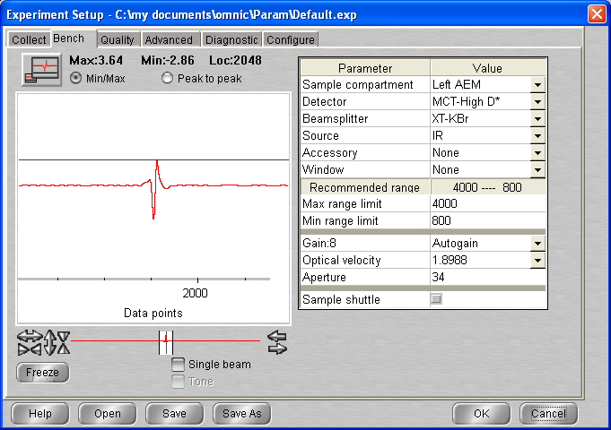

## Background scan(s) #1

**13:30 BG20210816_01**

512 scans res = 1 cm-1 signal = 3.67  
 p = 5 * 10-10 mbar T = 19.9K

## Deposition 1#: C2H6 @ 19.9 K

14:00 10 min @ 1x10-7 mbar C2H6

- Initial Temperature: 19.9 K

- Initial pressure: 5.0 * 10 -10 mbar

- Initial gas cell pressure: 1.035 (Ethane)

- Deposition pressure: 1x10-7

- Laser signal: 326.2 mV

- Deposition time: 10 min

- final gas cell pressure = 1.021 Torr

**14:12** laser Head rotated

Gas cell valve open for pumping

**14:15 C2H6_ASW_2021_08_16_0001 (bg1)**

512 scans 1 cm-1 res signal 3.74  
p =5.0 x 10-10 mbar T = 19.9 K

**14:30 C2H6_ASW_2021_08_16_0002 (bg1)**

512 scans 1 cm-1 res signal 3.73  
p =5.0 x 10-10 mbar T = 19.9 K

**15:00 BG20210816_02**

512 scans res = 1 cm-1 signal = 3.67  
 p = 5 * 10-10 mbar T = 19.9K

## Deposition 2#: H2O @ 19.9 K

15:30 20 min @ 1x10-7 mbar ASW

- Initial Temperature: 19.9 K

- Initial pressure: 5.0 * 10 -10 mbar

- Initial gas cell pressure: 0.734 (Water)

- Deposition pressure: 1x10-7

- Laser signal: 324.6 mV

- Deposition time: 20 min

- final gas cell pressure = 0.610 Torr

**15:52** laser Head rotated

Gas cell valve open for pumping

**16:00 C2H6_ASW_2021_08_16_0003 (bg2)**

512 scans 1 cm-1 res signal 3.72  
p =mbar T = 19.9 K

**16:15 C2H6_ASW_2021_08_16_0004 (bg1)**

512 scans 1 cm-1 res signal 3.72  
p =2.0 x 10-9 mbar T = 19.9 K

**16:30 BG20210816_03**

512 scans res = 1 cm-1 signal = 3.72  
 p = 1.5 * 10-9 mbar T = 19.9K

## Deposition #: C2H6 @ 20 K

15:30 10 min @ 1x10-7 mbar C2H6

- Initial Temperature: 20 K

- Initial pressure: 1.1 * 10 -9 mbar

- Initial gas cell pressure: 1.274 (C2H6)

- Deposition pressure: 1x10-7

- Laser signal: 322.7 mV

- Deposition time: 10 min

- final gas cell pressure = 1.259 Torr

**17:12** laser Head rotated

Gas cell valve open for pumping

LASER OFF

**17:15 C2H6_ASW_2021_08_16_0005 (bg3)**

512 scans 1 cm-1 res signal 3.72  
p = 1 * 10-9 mbar T = 19.9 K

**17:30 C2H6_ASW_2021_08_16_0006 (bg1)**

512 scans 1 cm-1 res signal 3.71  
p =mbar T = 19.9 K

**17:45 C2H6_ASW_2021_08_16_0007 (bg1)**

512 scans 1 cm-1 res signal 3.71  
p = 7.5 * 10-10mbar T = 19.9 K

18 :00 Macro 20 scans

Exit at loop 11 up to scan 18

20:41 MCT Detector cooled

**21:00 C2H6_ASW_2021_08_16_0019 (bg1)**

512 scans 1 cm-1 res signal 3.70  
p = 5 * 10-10mbar T = 19.9 K

21 :15 Macro 80 scan exit at loop 60 up to scan 79

17/08/2021

11:24 MCT Detector cooled

**12:00 C2H6_ASW_2021_08_16_0080 (bg1)**

512 scans 1 cm-1 res signal 3.72  
p = 5 * 10-10mbar T = 19.7 K

12 :15 Macro 20 scans (loop 12 – too many bad scans – data collection has stopped 15 :44)

Exit at loop 19 (up to scan)

**17:30 C2H6_ASW_2021_08_16_0099 (bg1)**

512 scans 1 cm-1 res signal 3.72  
p = 5 * 10-10mbar T = 19.7 K

Messed up with the ramp … (went to 40 and the down)

**17:45 C2H6_ASW_2021_08_16_0100 (bg1)**

512 scans 1 cm-1 res signal 3.72  
p = T = 21.0 K

**18:00 C2H6_ASW_2021_08_16_0101 (bg1)**

512 scans 1 cm-1 res signal 3.65  
p = 6.8 * 10-10mbar T = 19.8 K

18 :17 MCT Detector cooled

**18:30 C2H6_ASW_2021_08_16_0102 (bg1)**

512 scans 1 cm-1 res signal 3.65  
p = 6.8 * 10-10mbar T = 19.8 K

Macro 60 scans (exit at loop 59 up to scan 161)

18/08/2021

9 :00 MCT Detector cooled

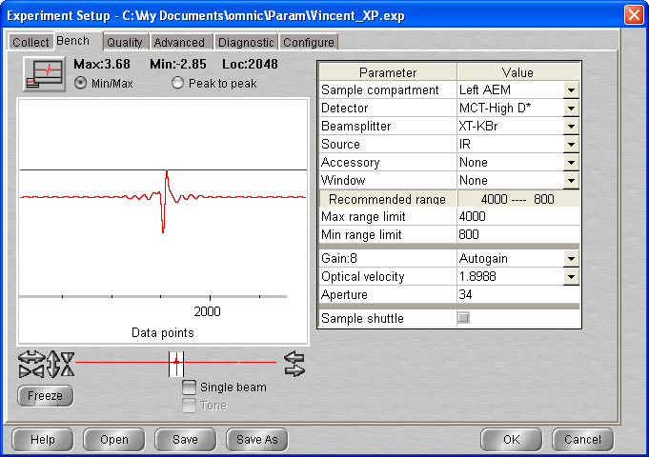

**09:45 C2H6_ASW_2021_08_16_0162 (bg1)**

512 scans 1 cm-1 res signal 3.65  
p = 5 * 10-10mbar T = 19.8 K

10 :00 Macro 20 scans (exit at loop 6 – problem !)

12:29Restart omnic

**12:30 C2H6_ASW_2021_08_16_0168 (bg1)**

512 scans 1 cm-1 res signal 3.50  
p = 5 * 10-10mbar T = 19.7 K

**13:45 C2H6_ASW_2021_08_16_0169 (bg1)**

512 scans 1 cm-1 res signal 3.65  
p = 5 * 10-10mbar T = 19.7 K

19/08/2021

12 :30 MCT Detector cooled

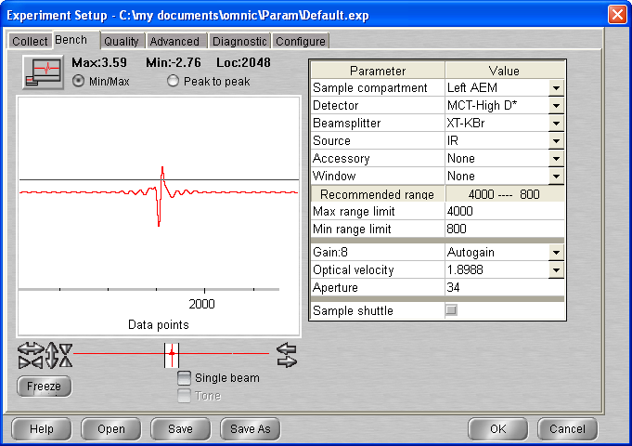

**13:30 C2H6_ASW_2021_08_16_0170 (bg1)**

512 scans 1 cm-1 res signal 3.73  
p = 5 * 10-10mbar T = 19.7 K

13 :45 Macro 20 scans

18 :30 MCT Detector cooled

**18:45 C2H6_ASW_2021_08_16_0191 (bg1)**

512 scans 1 cm-1 res signal 3.64  
p = 5 * 10-10mbar T = 19.7 K

19 :00 Macro 80 scans (exit at loop 66 up to scan 257)

20/08/2021

11:32 MCT Detector cooled

**11:45 C2H6_ASW_2021_08_16_0258 (bg1)**

512 scans 1 cm-1 res signal 3.73  
p = 5 * 10-10mbar T = 19.6 K

**12:00 C2H6_ASW_2021_08_16_0259 (bg1)**

512 scans 1 cm-1 res signal 3.76  
p = 5 * 10-10mbar T = 19.6 K

12 :20 Macro 10 scan

**15:00 C2H6_ASW_2021_08_16_0270 (bg1)**

512 scans 1 cm-1 res signal 3.67  
p = 5 * 10-10mbar T = 19.6 K

**15:15 C2H6_ASW_2021_08_16_0271 (bg1)**

512 scans 1 cm-1 res signal 3.66  
p = 5 * 10-10mbar T = 19.6 K

**17:00 C2H6_ASW_2021_08_16_0272 (bg1)**

512 scans 1 cm-1 res signal 3.24  
p = 5 * 10-10mbar T = 19.6 K

22/08/2021

(computer has restarted – had to recover labbok (no loss of information) – Omnic restarted)

12 :20 MCT Detector cooled

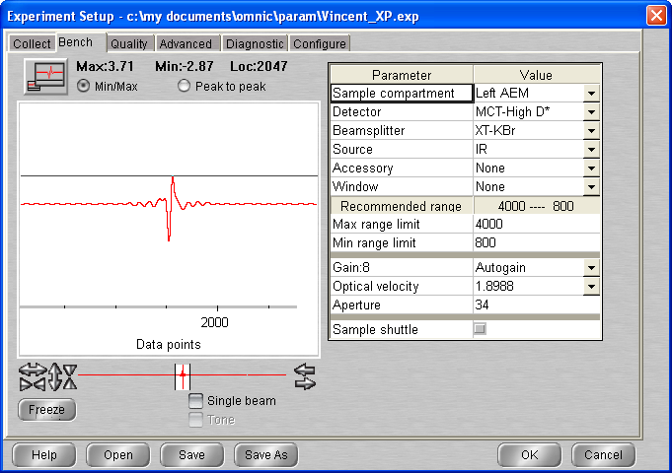

**14:00 C2H6_ASW_2021_08_16_0273 (bg1)**

512 scans 1 cm-1 res signal 3.71  
p = 5 * 10-10mbar T = 19.6 K

**14:30 C2H6_ASW_2021_08_16_0274 (bg1)**

512 scans 1 cm-1 res signal 3.71  
p = 5 * 10-10mbar T = 19.6 K

15 :00 Macro 10 scans (exit at loop 5)

**16:30 C2H6_ASW_2021_08_16_0280 (bg1)**

512 scans 1 cm-1 res signal 3.71  
p = 5 * 10-10mbar T = 19.6 K

## Annealing to 30 K

**16:45 C2H6_ASW_2021_08_16_0280 (bg1)**

512 scans 1 cm-1 res signal 3.66  
p = 5 * 10-10mbar T = 19.6 K

**17:00 C2H6_ASW_2021_08_16_0281 (bg1)**

512 scans 1 cm-1 res signal 3.66  
p = 7.7 * 10-10mbar T = 29.9 K

**17:30 C2H6_ASW_2021_08_16_0282 (bg1)**

512 scans 1 cm-1 res signal 3.66  
p = 7.7 * 10-10mbar T = 29.9 K

## Annealing to 40 K

**18:00 C2H6_ASW_2021_08_16_0283 (bg1)**

512 scans 1 cm-1 res signal 3.66  
p = 5 * 10-10mbar T = 19.6 K

**18:15 C2H6_ASW_2021_08_16_0284 (bg1)**

512 scans 1 cm-1 res signal 3.66  
p = 5 * 10-10mbar T = 19.6 K

Time out problem – go home

23/08/2021

10 :55 MCT Detector cooled

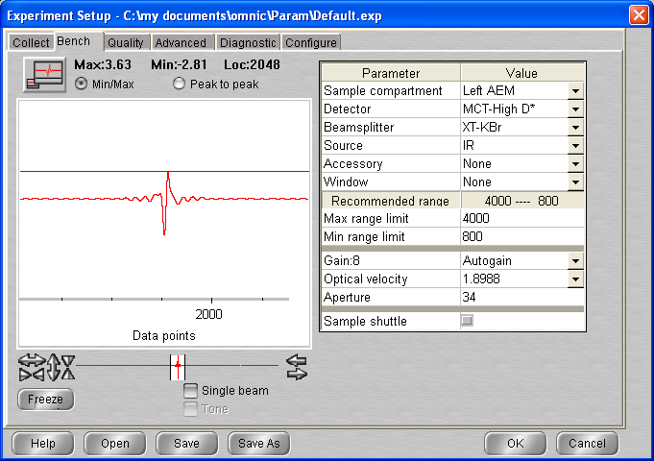

**11:30 C2H6_ASW_2021_08_16_0285 (bg1)**

512 scans 1 cm-1 res signal 3.63  
p = 5 * 10-10mbar T = 40 K

Lots of time out, bad scans … Why ?

**12:00 C2H6_ASW_2021_08_16_0286 (bg1)**

512 scans 1 cm-1 res signal 3.63  
p = 5 * 10-10mbar T = 40 K

Computer turned off (on its own)

**14:00 C2H6_ASW_2021_08_16_0287 (bg1)**

512 scans 1 cm-1 res signal 3.60  
p = 5 * 10-10mbar T = 40 K

**15:30 C2H6_ASW_2021_08_16_0288 (bg1)**

512 scans 1 cm-1 res signal 3.60  
p = 5 * 10-10mbar T = 40 K

27/08/2021

12 :00 MCT Detector cooled

**14:30 C2H6_ASW_2021_08_16_0289 (bg1)**

512 scans 1 cm-1 res signal 3.60  
p = 5 * 10-10mbar T = 40 K

13/09

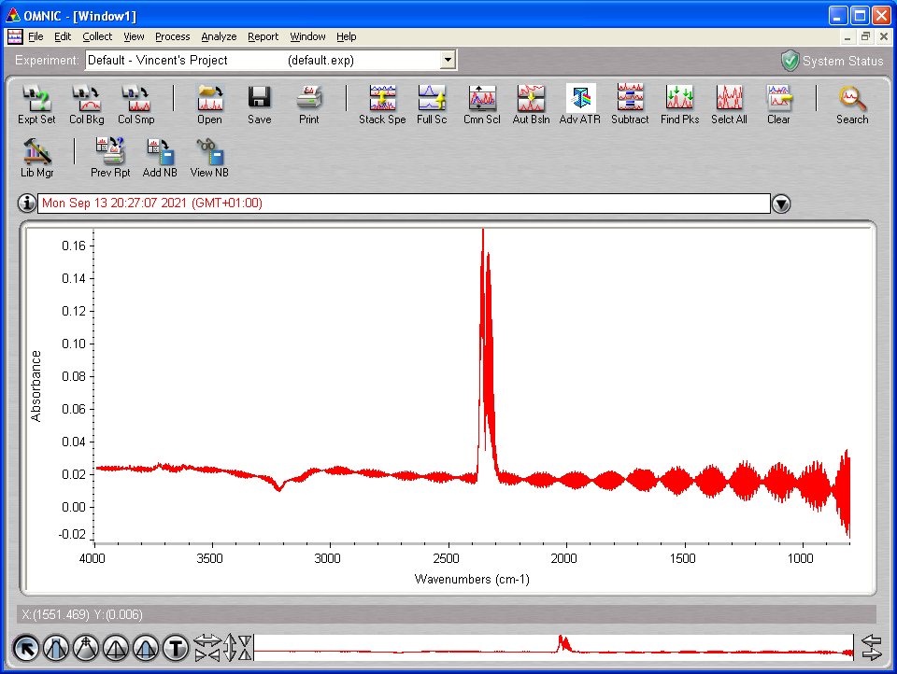

# Wednesday 15th Sep 2021 (VD) – ethane only (clean dep)

10:00 Cryo-on

10:00 Laser On

10:45 MCT Detector cooled

11:05: T = 67.5 K ; P = 5.8 * 10-9 mbar

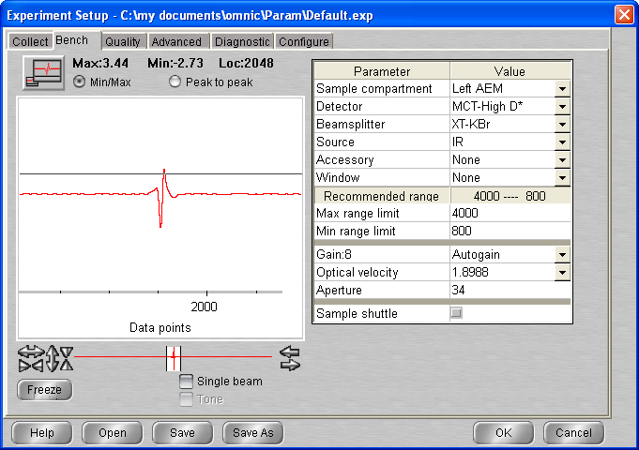

## Background scan(s) #1

**14:00 BG20210915_01**

512 scans res = 1 cm-1 signal = 3.45  
 p = 4.1 * 10-9 mbar T = 20K

## Deposition #1: C2H6 @ 20.0 K

17:45 Head rotated

18:00 20 min @ 1x10-7 mbar C2H6

- Initial Temperature: 20.0 K

- Initial pressure: 3.4*10-9 mbar

- Initial gas cell pressure: (before introducing ethane reading = 0.057) – 1.046

- Deposition pressure: 1x10-7

- Laser signal: 305.1 mV

- Deposition time: 20 min

- pressure after deposition 3.3 * 10-9 mbar

- final gas cell pressure = 1.019 Torr

**18:22** laser Off / Head rotated

**18:32 C2H6_2021_09_15_0001**

512 scans 1 cm-1 res signal 3.60  
p = 3.2 x 10-9 mbar T = 20.0 K

Problem with spectro …

**19:40 C2H6_2021_09_15_0002**

512 scans 1 cm-1 res signal 3.70  
p = 3.2 x 10-9 mbar T = 20.0 K

**20:05 C2H6_2021_09_15_0003**

512 scans 1 cm-1 res signal 3.68  
p = 3.2 x 10-9 mbar T = 20.0 K

16/09

10 :15 MCT Detector cooled

**10:45 C2H6_2021_09_15_0004**

512 scans 1 cm-1 res signal 3.45  
p = 2.7 x 10-9 mbar T = 20.0 K

**11:00 C2H6_2021_09_15_0005**

512 scans 1 cm-1 res signal 3.63  
p = 2.7 x 10-9 mbar T = 20.0 K

**11:15 C2H6_2021_09_15_0006**

512 scans 1 cm-1 res signal 3.63  
p = 2.7 x 10-9 mbar T = 20.0 K

**11:30 C2H6_2021_09_15_0007**

512 scans 1 cm-1 res signal 3.63  
p = 2.6 x 10-9 mbar T = 20.0 K

**11:45 C2H6_2021_09_15_0008**

512 scans 1 cm-1 res signal 3.67  
p = 2.6 x 10-9 mbar T = 20.0 K

**12:00 C2H6_2021_09_15_0009**

512 scans 1 cm-1 res signal 3.67  
p = 2.6 x 10-9 mbar T = 20.0 K

**13:00 C2H6_2021_09_15_0010**

512 scans 1 cm-1 res signal 3.67  
p = 2.6 x 10-9 mbar T = 20.0 K

## Annealing to 30 K

**14:00 C2H6_2021_09_15_0011**

512 scans 1 cm-1 res signal 3.66  
p = 2.6 x 10-9 mbar T = 20.0 K

**14:15 C2H6_2021_09_15_0012**

512 scans 1 cm-1 res signal 3.66  
p = 2.7 x 10-9 mbar T = 30.0 K

**14:30 C2H6_2021_09_15_0013**

512 scans 1 cm-1 res signal 3.66  
p = 2.6 x 10-9 mbar T = 30.0 K

**14:45 C2H6_2021_09_15_0014**

512 scans 1 cm-1 res signal 3.66  
p = 2.5 x 10-9 mbar T = 30.0 K

## Annealing to 40 K

**15:00 C2H6_2021_09_15_0015**

512 scans 1 cm-1 res signal 3.66  
p = 2.5 x 10-9 mbar T = 30.0 K

**15:15 C2H6_2021_09_15_0016**

512 scans 1 cm-1 res signal 3.66  
p = 4.9 x 10-9 mbar T = 39.8 K

**15:30 C2H6_2021_09_15_0017**

512 scans 1 cm-1 res signal 3.66  
p = 3.3 x 10-9 mbar T = 40K

**15:45 C2H6_2021_09_15_0018**

512 scans 1 cm-1 res signal 3.66  
p = 3.3 x 10-9 mbar T = 40K

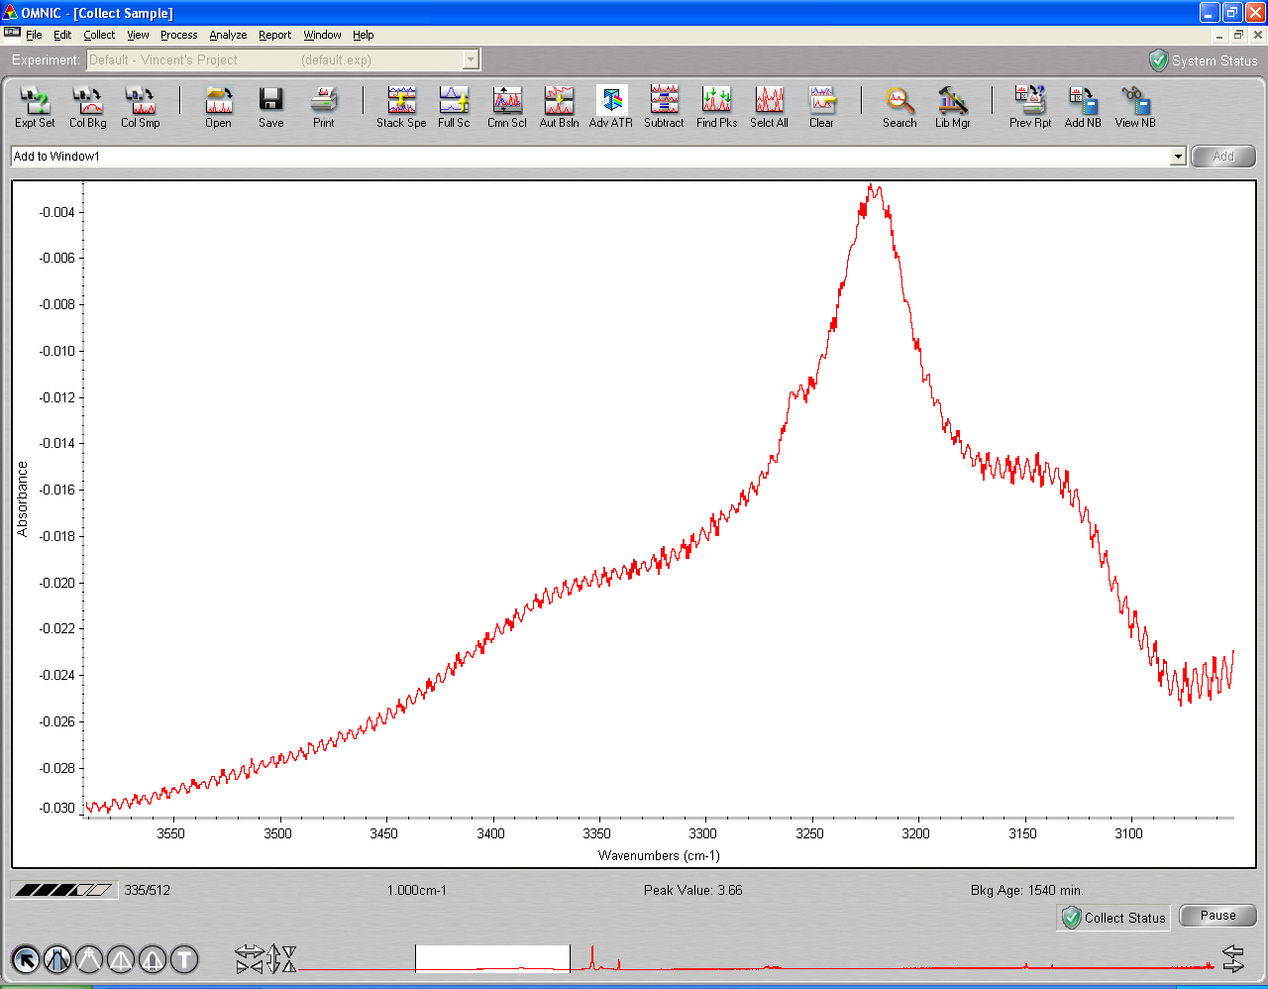

Peak at 3258 ?

## Annealing to 50 K

**16:00 C2H6_2021_09_15_0019**

512 scans 1 cm-1 res signal 3.67  
p = 2.9 x 10-9 mbar T = 40K

**16:15 C2H6_2021_09_15_0020**

512 scans 1 cm-1 res signal 3.67  
p = T = 50K

**16:30 C2H6_2021_09_15_0021**

512 scans 1 cm-1 res signal 3.67  
p = 2.9 x 10-9 mbar T = 50K

**16:45 C2H6_2021_09_15_0022**

512 scans 1 cm-1 res signal 3.68  
p = 2.8 x 10-9 mbar T = 50K

## Annealing to 55 K

**17:00 C2H6_2021_09_15_0023**

512 scans 1 cm-1 res signal 3.68  
p = 2.8 x 10-9 mbar T = 50K

**17:15 C2H6_2021_09_15_0024**

512 scans 1 cm-1 res signal 3.68  
p = 3.4 x 10-9 mbar T = 55K

17 :30 Macro 20 scans up to scan 44

17/09/2021

11 :45 MCT Detector cooled

**13:15 C2H6_2021_09_15_0045**

512 scans 1 cm-1 res signal 3.51  
p = 2.5 x 10-9 mbar T = 55K

**13:30 C2H6_2021_09_15_0046**

512 scans 1 cm-1 res signal 3.74  
p = 2.5 x 10-9 mbar T = 55K

## Annealing to 60 K

**13:45 C2H6_2021_09_15_0047**

512 scans 1 cm-1 res signal 3.74  
p = 2.5 x 10-9 mbar T = 55K

**14:00 C2H6_2021_09_15_0048**

512 scans 1 cm-1 res signal 3.74  
p = 2.5 x 10-8 mbar T = 60K

14 :15 Macro 20 scans Exit at loop 5

## Annealing to 65 K

**15:30 C2H6_2021_09_15_0054**

512 scans 1 cm-1 res signal 3.71  
p = 3.3 x 10-9 mbar T = 60.6K

**15:45 C2H6_2021_09_15_0055**

512 scans 1 cm-1 res signal 3.68  
p = 8.1 x 10-7 mbar T = 65K

16 :00 Macro 20 scans exit at loop 7 (up to scan 61)

17:33 Cryo off

# Saturday 18th Sep 2021 (VD) – ethane at 40K dep

14:40 T = 278.6 P = 3.34 * 10-8

14:41 Cryo-on

14:41 Laser On

15:30 MCT Detector cooled

16:05 T = 20.2

P = 3.3 * 10-9

Heater set up 40K

16:30

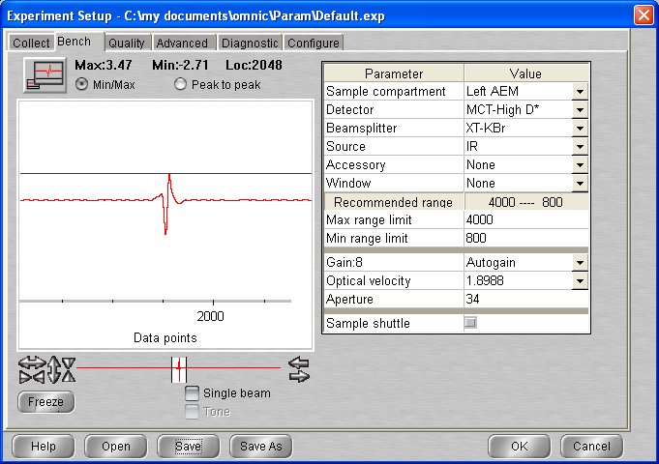

## Background scan(s) #1

**16:35 BG20210918_01**

512 scans res = 1 cm-1 signal = 3.50  
 p = 3.6 * 10-9 mbar T = 40.0

## Deposition #2: C2H6 @ 40 K

16:50 Head rotated

17:00 20 min @ 1x10-7 mbar C2H6

- Initial Temperature: 40.0 K

- Initial pressure: 3.3*10-9 mbar

- Initial gas cell pressure: 1.018 (same as previous deposition)

- Deposition pressure: 1x10-7

- Laser signal: 325.1 mV

- Deposition time: 20 min

- pressure after deposition 3.3 * 10-9 mbar

- final gas cell pressure = 0.993 Torr

**17:20** laser Off / Head rotated

**17:25 C2H6_2021_09_18_0001**

512 scans 1 cm-1 res signal 3.68  
p = 3.1 x 10-9 mbar T = 40.0K

17 :40 Macro 20 scans (exit6 at loop 7 up to scan )

## Annealing to 50 K

**19:20 C2H6_2021_09_18_0009**

512 scans 1 cm-1 res signal 3.60  
p = 2.9 x 10-9 mbar T = 40.0 K

**19:35 C2H6_2021_09_18_0010**

512 scans 1 cm-1 res signal 3.59  
p = 2.9 x 10-9 mbar T = 50.0 K

**19:50 C2H6_2021_09_18_0011**

512 scans 1 cm-1 res signal 3.59  
p = 2.9 x 10-9 mbar T = 50.0 K

## Annealing to 65 K

**20:05 C2H6_2021_09_18_0012**

512 scans 1 cm-1 res signal 3.60  
p = 2.9 x 10-9 mbar T = 50.0 K

20:20 Macro 20 scans (exit at loop7)

22:00 cryo off – heater off

# Sunday 19th Sep 2021 (VD) – ethane at 20K for 30 min dep

14:40 T = 276.7 P = 2.7 * 10-8

12:42 T set up to 300K

12:52 T = 300.4 K; P = 9.6 * 10-8 mbar (heater stopped)

12:55 Cryo-on

12:55 Laser On

13:23 MCT Detector cooled

14:57: T = 19.9 P = 3.7 e-9

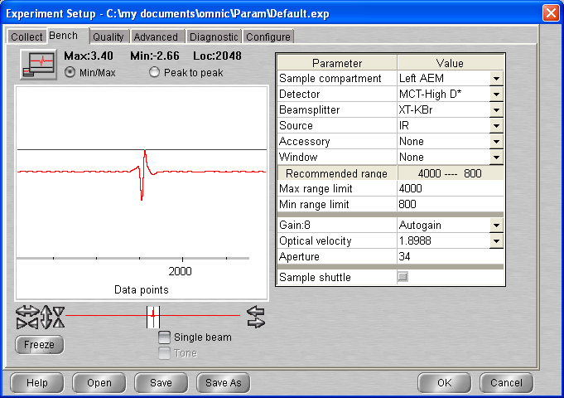

## Background scan(s) #1

**15:00 BG20210919_01**

512 scans res = 1 cm-1 signal = 3.40  
 p = 3.6 * 10-9 mbar T = 19.9

## Deposition #3: C2H6 @ 19.9 K

15:16 Head rotated

15:20 30 min @ 1x10-7 mbar C2H6

- Initial Temperature: 19.9 K

- Initial pressure: 3.4*10-9 mbar

- Initial gas cell pressure: 0.993

- Deposition pressure: 1x10-7

- Laser signal: 325.6 mV

- Deposition time: 30 min

- pressure after deposition 3.0 * 10-9 mbar

- final gas cell pressure = 0.955 Torr

**15:50** laser Off / Head rotated

**16:00 C2H6_2021_09_19_0001**

512 scans 1 cm-1 res signal 3.63  
p = 2.8 x 10-9 mbar T = 19.9K

**16:15 C2H6_2021_09_19_0002**

512 scans 1 cm-1 res signal 3.63  
p = 2.8 x 10-9 mbar T = 19.9K

## Annealing to 40 K

**16:30 C2H6_2021_09_15_0003**

512 scans 1 cm-1 res signal 3.61  
p = 2.8 x 10-9 mbar T = 19.9

**16:45 C2H6_2021_09_15_0004**

512 scans 1 cm-1 res signal 3.61  
p = 2.8 x 10-9 mbar T = 40

**17:00 C2H6_2021_09_15_0005**

512 scans 1 cm-1 res signal 3.60  
p = 2.8 x 10-9 mbar T = 40

## Annealing to 65 K

**17:15 C2H6_2021_09_15_0006**

512 scans 1 cm-1 res signal 3.60  
p = 2.8 x 10-9 mbar T = 40

17 :30 Macro 20 scan (exit at loop 13)

20:30 cryo off, heater off

# Monday 20th Sep 2021 (VD) – ethane on top ASW 20K

10:12 T = 276 K P = 2.4 * 10-8

10:15 Cryo-on

10:15 Laser On

11:10 MCT Detector cooled

12:27 T = 19.7K P = 2.3 * 10 e-9

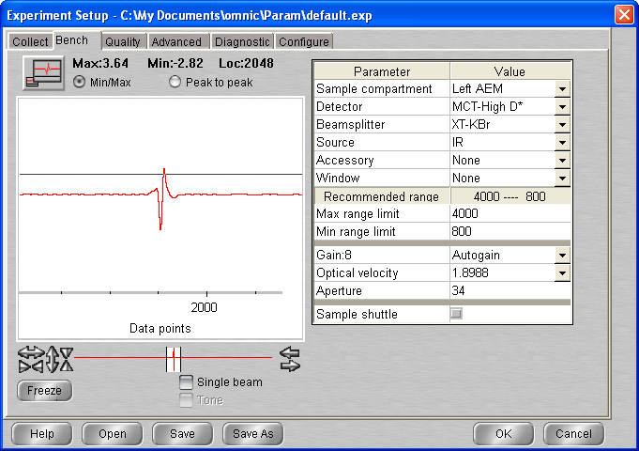

## Background scan(s) #1

**12:40 BG20210920_01**

512 scans res = 1 cm-1 signal = 3.72  
 p = 2.2 * 10-9 mbar T = 19.7

17 :00 Head rotated (laser moved so put it back in place)

## Deposition 1: H2O @ 20K

13:15 20 min @ 1x10-7 mbar H2O

- Initial Temperature: 19.7K

- Initial pressure: 2.1 * 10-9 mbar

- Initial gas cell pressure: 7.73 Torr

- Deposition pressure: 1 * 10-7

- Laser signal: 326.0 mV

- Deposition time: 20 min

- pressure after deposition 9.3 e-9

- final gas cell pressure = 6.63 Torr

**13:36** Head rotated

**13:40 C2H6_ASW_2021_09_20_0001**

512 scans 1 cm-1 res signal 3.77  
p = 5 x 10-9 mbar T = 19.7K

**14:30 C2H6_ASW_2021_09_20_0002**

512 scans 1 cm-1 res signal 3.75  
p = 2.2 x 10-9 mbar T = 19.7

**14:45 C2H6_ASW_2021_09_20_0003**

512 scans 1 cm-1 res signal 3.75  
p = 2.1 x 10-9 mbar T = 19.7K

**15:00 BG20210920_02**

512 scans res = 1 cm-1 signal = 3.75  
 p = 1.9 * 10-9 mbar T = 19.7

## Deposition 2: C2H6 @ 19.7 K

15:30 20 min @ 1x10-7 mbar C2H6

- Initial Temperature: 19.7 K

- Initial pressure: 1.8*10-9 mbar

- Initial gas cell pressure: 1.232

- Deposition pressure: 1x10-7

- Laser signal: 324.7 mV

- Deposition time: 20 min

- pressure after deposition 3 * 10-9 mbar

- final gas cell pressure = 1.167 Torr

**15:52** laser Off / Head rotated

Problem with spectro (had to switch on/off)

**16:07 C2H6_ASW_2021_09_20_0004 (bg1)**

512 scans 1 cm-1 res signal 3.81  
p = 2.1 x 10-9 mbar T = 19.7K

Very few ethane again (similar to 02/24) – also water contribution seems to decrease …

**16:30 C2H6_ASW_2021_09_20_0005 (bg1)**

512 scans 1 cm-1 res signal 3.81  
p = 1.9 x 10-9 mbar T = 19.7K

**16:45 C2H6_ASW_2021_09_20_0006 (bg1)**

512 scans 1 cm-1 res signal 3.81  
p = 1.9 x 10-9 mbar T = 19.7K

## Annealing to 40 K

**17:00 C2H6_ASW_2021_09_20_0007**

512 scans 1 cm-1 res signal 3.82  
p = 1.8 x 10-9 mbar T = 19.7

**17:15 C2H6_ASW_2021_09_20_0008**

512 scans 1 cm-1 res signal 3.78  
p = 4.5 x 10-7 mbar T = 39.7

**17:30 C2H6_ASW_2021_09_20_0009**

512 scans 1 cm-1 res signal 3.77  
p = 1.9 x 10-7 mbar T = 40

**17:45 C2H6_ASW_2021_09_20_0010**

512 scans 1 cm-1 res signal 3.76  
p = 8.6 x 10-8 mbar T = 40

## Annealing to 65 K

**18:00 C2H6_ASW_2021_09_20_0011**

512 scans 1 cm-1 res signal 3.75  
p = 7.7 x 10-8 mbar T = 40

**18:15 C2H6_ASW_2021_09_20_0012**

512 scans 1 cm-1 res signal 3.73  
p = 3.9 x 10-8 mbar T = 65

**18:30 C2H6_ASW_2021_09_20_0013**

512 scans 1 cm-1 res signal 3.73  
p = 1.5 x 10-8 mbar T = 65

**18:45 C2H6_ASW_2021_09_20_0014**

512 scans 1 cm-1 res signal 3.72  
p = 1.0 x 10-8 mbar T = 65

## Annealing to 90 K

**19:00 C2H6_ASW_2021_09_20_0015**

512 scans 1 cm-1 res signal 3.72  
p = 7.7 x 10-8 mbar T = 40

19 :15 Macro 3 scan

## Annealing to 120 K

**20:00 C2H6_ASW_2021_09_20_0019**

512 scans 1 cm-1 res signal 3.71  
p = 5.3 x 10-9 mbar T = 90

20 :15 Macro 3 scan

## Annealing to 135 K

**21:00 C2H6_ASW_2021_09_20_0023**

512 scans 1 cm-1 res signal 3.71  
p = 6.0 x 10-9 mbar T = 120

21 :15 Macro 2 scans

21 :48 MCT Detector cooled

**22:15 C2H6_ASW_2021_09_20_0026**

512 scans 1 cm-1 res signal 3.71  
p = 2.9 x 10-8 mbar T = 135

22 :30 Macro 80 scan exit at loop 58 up to scan 84

21/09/2021

12:06 MCT Detector cooled

12:28

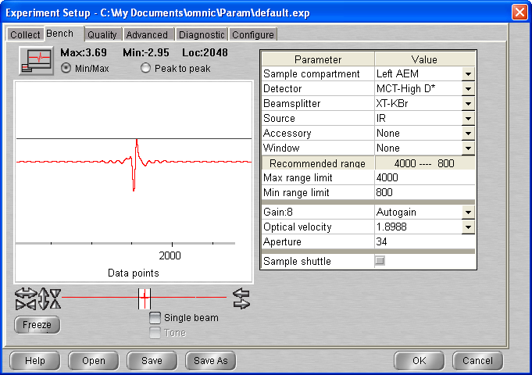

**12:30 C2H6_ASW_2021_09_20_0085**

512 scans 1 cm-1 res signal 3.71  
p = 1.3 x 10-8 mbar T = 135

12 :45 Macro 80 scans exit at loop 33 (I guess) up to scan 119

20:42 MCT Detector cooled

**21:00 C2H6_ASW_2021_09_20_0120**

512 scans 1 cm-1 res signal 3.68  
p = 1.0 x 10-8 mbar T = 135

21 :15 Macro 80 exit at loop 63

22/09/2021

11:57 MCT Detector cooled

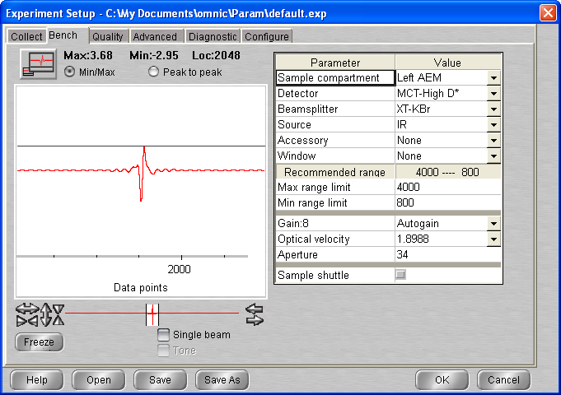

**12 :15 C2H6_ASW_2021_09_20_0184**

512 scans 1 cm-1 res signal 3.68  
p = 8.8 x 10-9 mbar T = 134.9

Macro 80 scans exit at loop 21

## Annealing to 140 K

**17:30 C2H6_ASW_2021_09_20_0206**

512 scans 1 cm-1 res signal 3.69  
p = 8.6 x 10-9 mbar T = 135K

**17:45 C2H6_ASW_2021_09_20_0207**

512 scans 1 cm-1 res signal 3.69  
p = 3.0 x 10-8 mbar T = 140K

**18:00 C2H6_ASW_2021_09_20_0208**

512 scans 1 cm-1 res signal 3.69  
p = 3.1 x 10-8 mbar T = 140K

18 :15 Heater off / cryo off

# Friday 23rd Sep 2021 (VD) – ethane on top ASW 20K II

10:10 T = 277.5 K P = 2.7 * 10-8

10:11 Cryo-on

10:11 Laser On

11:45 MCT Detector cooled

11:45 T = 20K P = 2.6 * 10 e-9

12:23 T = 19.8 P = 2.3 * 10-9 mbar

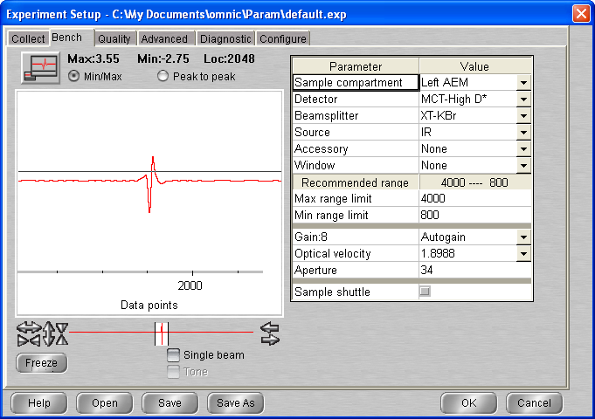

## Background scan(s) #1

**12:30 BG20210923_01**

512 scans res = 1 cm-1 signal = 3.69  
 p = 2.3 * 10-9 mbar T = 19.8

## Deposition 1: H2O @ 20K

13:05 20 min @ 1x10-7 mbar H2O

- Initial Temperature: 19.7K

- Initial pressure: 2.2 * 10-9 mbar

- Initial gas cell pressure: 7.70 Torr

- Deposition pressure: 1 * 10-7

- Laser signal: 327.7 mV

- Deposition time: 20 min

- pressure after deposition 9.1 e-9

- final gas cell pressure = 6.54 Torr

13:26 Head rtotatexd

**13:30 C2H6_ASW_2021_09_23_0001**

512 scans 1 cm-1 res signal 3.71  
p = 5.0 x 10-9 mbar T = 19.8K

**13:50 C2H6_ASW_2021_09_23_0002**

512 scans 1 cm-1 res signal 3.70  
p = 2.8 x 10-9 mbar T = 19.8K

**14:05 BG20210923_02**

512 scans res = 1 cm-1 signal = 3.68  
p = 2.4 * 10-9 mbar T = 19.8

14 :20 Head rotated

## Deposition 2: C2H6 @ 20K

14:30 20 min @ 1x10-7 mbar H2O

- Initial Temperature: 19.8K

- Initial pressure: 2.1 * 10-9 mbar

- Initial gas cell pressure: 8.61 Torr

- Deposition pressure: 1 * 10-7

- Laser signal: 326.1 mV

- Deposition time: 20 min

- pressure after deposition 1.9 e-9

- final gas cell pressure = 8.35 Torr

14:50 Head rotated

**14:55 C2H6_ASW_2021_09_23_0003 (bg2)**

512 scans 1 cm-1 res signal 3.67  
p = 1.8 x 10-9 mbar T = 19.8K

**15:10 C2H6_ASW_2021_09_23_0004 (bg1)**

512 scans 1 cm-1 res signal 3.67  
p = 1.7 x 10-9 mbar T = 19.8K

**15:25 C2H6_ASW_2021_09_23_0005 (bg1)**

512 scans 1 cm-1 res signal 3.65  
p = 1.7 x 10-9 mbar T = 19.8K

**15:40 C2H6_ASW_2021_09_23_0006 (bg1)**

512 scans 1 cm-1 res signal 3.65  
p = 1.7 x 10-9 mbar T = 19.8K

## Annealing to 40 K

**16:00 C2H6_ASW_2021_09_23_0007**

512 scans 1 cm-1 res signal 3.63  
p = 1.7 x 10-9 mbar T = 19.8

Macro 3 scans

## Annealing to 65 K

**17:00 C2H6_ASW_2021_09_23_0011**

512 scans 1 cm-1 res signal 3.64  
p = 2 x 10-9 mbar T = 40

Macro 20 scans exit at loop 10 up to scan 21

**19:45 C2H6_ASW_2021_09_23_0022**

512 scans 1 cm-1 res signal 3.58  
p = 5.2 x 10-8 mbar T = 65

## Annealing to 90 K

**20:00 C2H6_ASW_2021_09_23_0023**

512 scans 1 cm-1 res signal 3.58  
p = 2 x 10-9 mbar T = 40

**20:15 C2H6_ASW_2021_09_23_0024**

512 scans 1 cm-1 res signal 3.58  
p = 1.9 x 10-8 mbar T = 89.7

20 :37 MCT detector cooled

**20:45 C2H6_ASW_2021_09_23_0025**

512 scans 1 cm-1 res signal 3.56  
p = 4.8 x 10-9 mbar T = 90

21 :00 Macro 80 scans exit at loop 55

**10:20 C2H6_ASW_2021_09_23_0081**

512 scans 1 cm-1 res signal 3.59  
p = 1.6 x 10-9 mbar T = 90

10 :38 MCT Detector cooled

**11:00 C2H6_ASW_2021_09_23_0082**

512 scans 1 cm-1 res signal 3.58  
p = 1.6 x 10-9 mbar T = 90

## Annealing to 120 K

**11:15 C2H6_ASW_2021_09_23_0083**

512 scans 1 cm-1 res signal 3.58  
p = 1.5 x 10-9 mbar T = 90

11 :30 Macro 8 scan

**13:30 C2H6_ASW_2021_09_23_0092**

512 scans 1 cm-1 res signal 3.60  
p = 2.4 x 10-9 mbar T = 120

## Annealing to 135 K

**13:45 C2H6_ASW_2021_09_23_0093**

512 scans 1 cm-1 res signal 3.61  
p = 1.5 x 10-9 mbar T = 120

14 :02 Macro 80 scan exit at loop 14 up to scan 107

17:27 MCT Detector cooled

**17:45 C2H6_ASW_2021_09_23_0108**

512 scans 1 cm-1 res signal 3.63  
p = 1.5 x 10-9 mbar T = 135

Macro 80 scan up to loop 60 (scan)

25/09/2021

15:11 MCT Detector cooled

**15:30 C2H6_ASW_2021_09_23_0167**

512 scans 1 cm-1 res signal 3.68  
p = 8.7 x 10-9 mbar T = 135

**16:00 C2H6_ASW_2021_09_23_0168**

512 scans 1 cm-1 res signal 3.68  
p = 8.6 x 10-9 mbar T = 135

**16:35 C2H6_ASW_2021_09_23_0169**

512 scans 1 cm-1 res signal 3.68  
p = 8.5 x 10-9 mbar T = 135

## Annealing to 140 K

**17:00 C2H6_ASW_2021_09_23_0170**

512 scans 1 cm-1 res signal 3.71  
p = 8.4 x 10-9 mbar T = 135

**17:25 C2H6_ASW_2021_09_23_0171**

512 scans 1 cm-1 res signal 3.71  
p = 3 x 10-8 mbar T = 140

**17:45 C2H6_ASW_2021_09_23_0172**

512 scans 1 cm-1 res signal 3.71  
p = 3 x 10-8 mbar T = 140

Cryo off – Heater man 0

# Monday 27th Sep 2021 (VD) – C2H6:ASW 1:1 mixture at 20K

9:44 T = 278.1 K P = 1.4 * 10-8

9:45 Cryo-on

9:45 Laser On

10:43 MCT Detector cooled

11:35 T = 19.8K P = 1.7 * 10 e-9

11:40

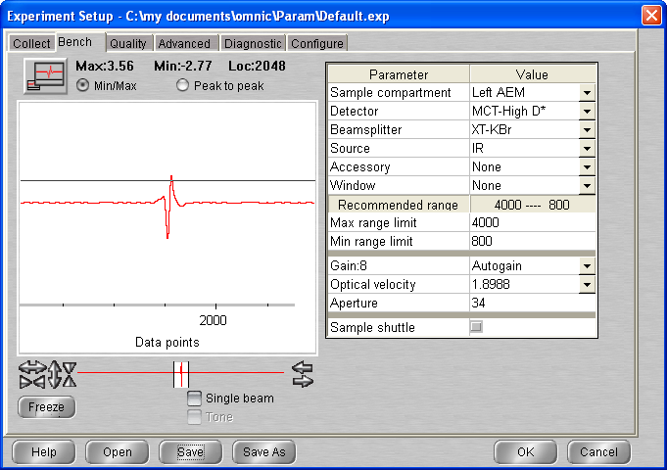

## Background scan(s) #1

**11:40 BG20210927_01**

512 scans res = 1 cm-1 signal = 3.66  
 p = 1.7 * 10-9 mbar T = 19.8

## Deposition : H2O:C2H6 @ 20K

12:35 20 min @ 1x10-7 mbar H2O

- Initial Temperature: 19.7K

- Initial pressure: 1.6 * 10-9 mbar

- Initial gas cell pressure: 1.011 Torr (0.560 ethane + 1.053 (-0.560) of water)

- Deposition pressure: 1 * 10-7

- Laser signal: 326.6 mV

- Deposition time: 20 min

- pressure after deposition 3.7 e-9

- final gas cell pressure = 0.968 Torr

12:56 Head rotated Laser off

**13:00 C2H6_ASW_2021_09_27_0001**

512 scans 1 cm-1 res signal 4.04  
p = 2.4 x 10-9 mbar T = 19.7K

13 :15 Macro 20 scans exit at loop 16

**17:00 C2H6_ASW_2021_09_27_0018**

512 scans 1 cm-1 res signal 3.98  
p = 1.3 x 10-9 mbar T = 19.7K

17:15 Macro 20 scans exit at loop 10 up to scan

19:40 MCT Detector cooled

**19:45 C2H6_ASW_2021_09_27_0029**

512 scans 1 cm-1 res signal 3.87  
p = 1.3 x 10-9 mbar T = 19.7K

20 :00 Macro 80 scans exit at loop 59 (up to scan 88)

28/09/2021

9:50 MCT Detector cooled

**10:00 C2H6_ASW_2021_09_27_0089**

512 scans 1 cm-1 res signal 3.83  
p = 1.1 x 10-9 mbar T = 19.6K

10 :15 Macro 20 scans EXIT AT LOOP 17

**14:20 C2H6_ASW_2021_09_27_0107**

512 scans 1 cm-1 res signal 3.83  
p = 1.0 x 10-9 mbar T = 19.6K

## Annealing to 25 K

**14:35 C2H6_ASW_2021_09_27_0108**

512 scans 1 cm-1 res signal 3.81  
p = 1.0 x 10-9 mbar T = 19.6

**14:50 C2H6_ASW_2021_09_27_0109**

512 scans 1 cm-1 res signal 3.81  
p = 1.0 x 10-9 mbar T = 25

15 :05 Macro 4 scans

## Annealing to 30 K

**16:05 C2H6_ASW_2021_09_27_0114**

512 scans 1 cm-1 res signal 3.82  
p = 1.1 x 10-9 mbar T = 25

**16:20 C2H6_ASW_2021_09_27_0115**

512 scans 1 cm-1 res signal 3.82  
p = 1.1 x 10-9 mbar T = 30

**16:35 C2H6_ASW_2021_09_27_0116**

512 scans 1 cm-1 res signal 3.82  
p = 1.1 x 10-9 mbar T = 30

16 :50 Macro 2 scans

## Annealing to 40 K

**17:20 C2H6_ASW_2021_09_27_0117**

512 scans 1 cm-1 res signal 3.83  
p = 1.1 x 10-9 mbar T = 30

17 :35 Macro 4 scans

18 :31 Macro 4 scans

19 :34 MCT Detector cooled

19 :40 Macro 80 scans exit at loop 62

29/09/2021

10:22 MCT Detector cooled

**11:15 C2H6_ASW_2021_09_27_0190**

512 scans 1 cm-1 res signal 3.79  
p = 1.1 x 10-9 mbar T = 40k

11 :30 Macro 20 scans

**16:45 C2H6_ASW_2021_09_27_0211**

512 scans 1 cm-1 res signal 3.82  
p = 1.0 x 10-9 mbar T = 40k

## Annealing to 60 K

**17:05 C2H6_ASW_2021_09_27_0212**

512 scans 1 cm-1 res signal 3.83  
p = 1.0 x 10-9 mbar T = 40

**17:20 C2H6_ASW_2021_09_27_0213**

512 scans 1 cm-1 res signal 3.83  
p = 3.5 x 10-8 mbar T = 59.7

17 : 36 MCT Detector refilled

**17:45 C2H6_ASW_2021_09_27_0214**

512 scans 1 cm-1 res signal 3.83  
p = 3.7 x 10-8 mbar T = 60

Macro 80 scans exit at loop 70 up to scan 283

30/09/2021

10:22 MCT Detector cooled

**10:30 C2H6_ASW_2021_09_27_0284 (unsaved for some reason)**

512 scans 1 cm-1 res signal 4.01  
p = 2 x 10-8 mbar T = 60

**10:45 C2H6_ASW_2021_09_27_0284**

512 scans 1 cm-1 res signal 3.83  
p = 1.3 x 10-8 mbar T = 59.3

(T dropping down slightly)

## Annealing to 70 K

**11:00 C2H6_ASW_2021_09_27_0285**

512 scans 1 cm-1 res signal 3.91  
p = 2 x 10-8 mbar T = 60

Macro 2 scans

## Annealing to 90 K

**11:45 C2H6_ASW_2021_09_27_0288**

512 scans 1 cm-1 res signal 3.87  
p = 1 x 10-7 mbar T = 70

12 :00 Macro 4 scans

## Annealing to 120 K

**13:05 C2H6_ASW_2021_09_27_0293**

512 scans 1 cm-1 res signal 3.81  
p = 2.2 x 10-9 mbar T = 90

13 :20 Macro 4 scans

## Annealing to 135 K

**14:20 C2H6_ASW_2021_09_27_0298**

512 scans 1 cm-1 res signal 3.81  
p = 2.8 x 10-9 mbar T = 120

14 :35 Macro 20 scans exit at loop 7

16:15 MCT DETECTOR COOLED

**16:20 C2H6_ASW_2021_09_27_0306**

512 scans 1 cm-1 res signal 3.76  
p = 2.2 x 10-8 mbar T = 135 k

Macro 70 scans (exit loop 61) up to scan 362 – 7:45

01/10/2021

10:37 MCT Detector colled

**11:00 C2H6_ASW_2021_09_27_0363**

512 scans 1 cm-1 res signal 3.82  
p = 6.7 x 10-9 mbar T = 135 k

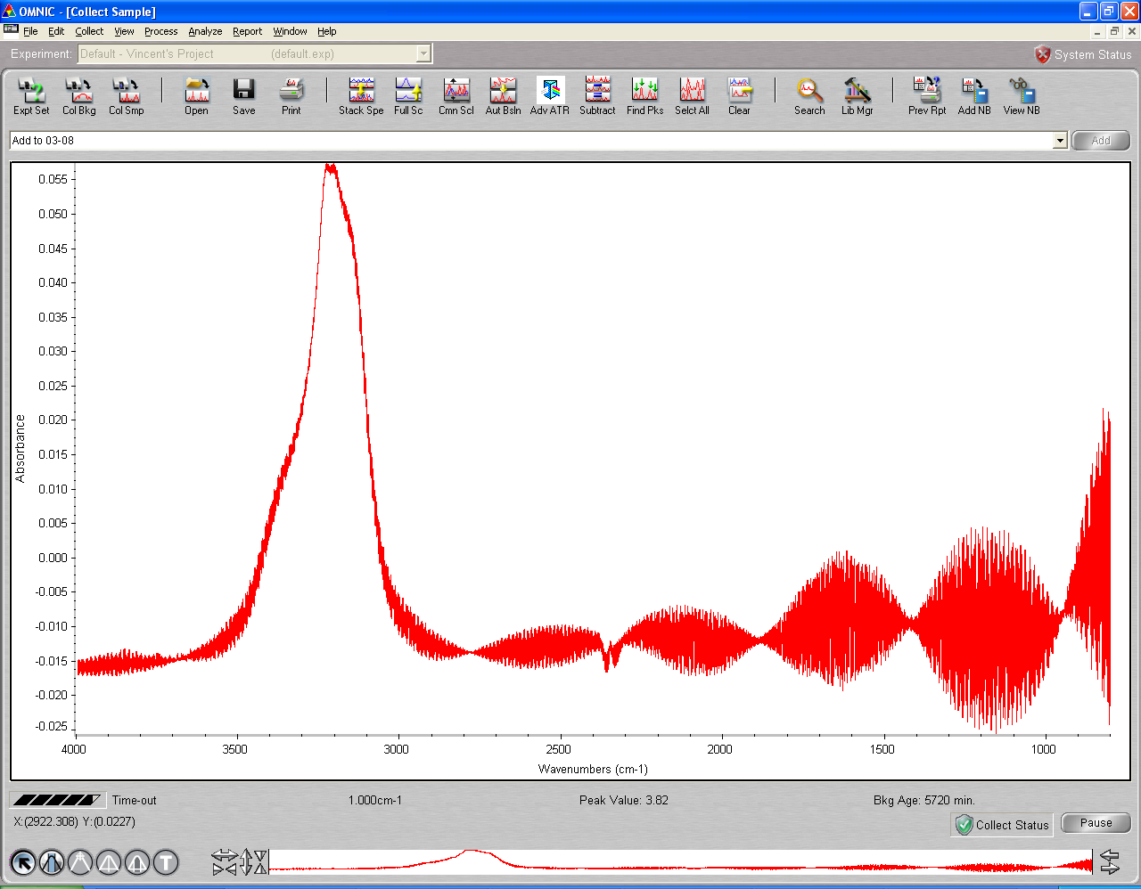

Collection stopped

Has the scan be saved ?

**11:40 C2H6_ASW_2021_09_27_0363**

512 scans 1 cm-1 res signal 3.82  
p = 6.7 x 10-9 mbar T = 135 k

**12:00 C2H6_ASW_2021_09_27_0364**

512 scans 1 cm-1 res signal 3.82  
p = 6.7 x 10-9 mbar T = 135 k

(lots of bad scans)

**13:25 C2H6_ASW_2021_09_27_0365**

512 scans 1 cm-1 res signal 3.82  
p = 6.1 x 10-9 mbar T = 135 k

**13:40 C2H6_ASW_2021_09_27_0366**

512 scans 1 cm-1 res signal 3.82  
p = 6.0 x 10-9 mbar T = 135 k

14 :00 Heater off cryo off

# Monday 04th Oct 2021 (VD) – C2H6 on top Ic 130K

9 :22 T = 278 P = 8.1 e-9 mbar

9:23 Cryo ON Laser On

11: 00 T = 19.8 P = 1.2 * 10-9 mbar

11:48 MCT Detector cooled

12:00 Heater set-up to 120K

12:05 Gas cell opened (0.947 initial P)

14:00

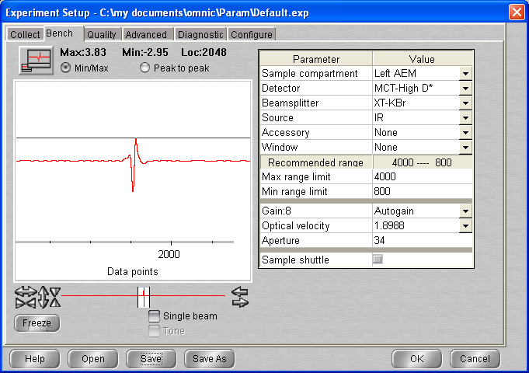

(decided to deposit at 130K)

Cf difference between 120K dep (10-14-blue) and 13K dep (10-30-red)

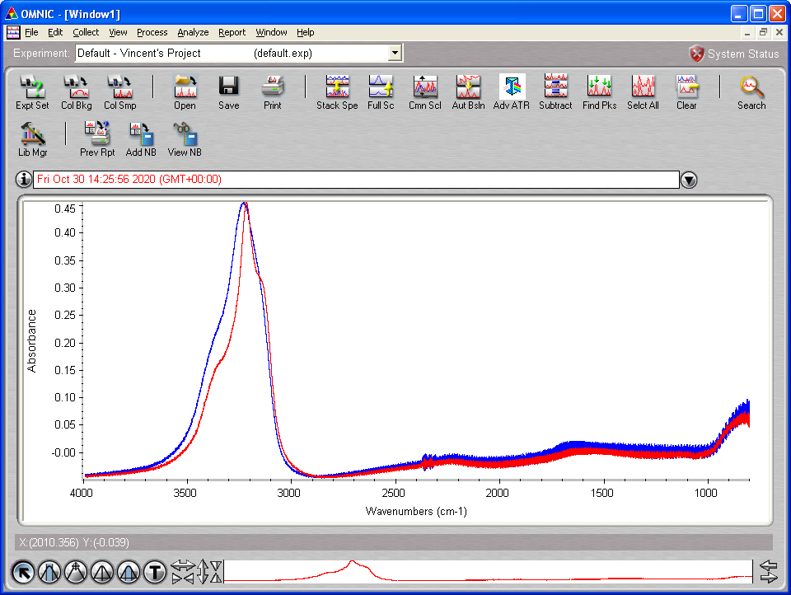

## Background scan(s) #1

**14:30 BG20211004_01**

512 scans res = 1 cm-1 signal = 3.85  
 p = 2.2 * 10-9 mbar T = 130

15 :40 Head rotated (T = 130K P = 1.7 e-9)

## Deposition 1: H2O @ 130K

15:45 20 min @ 1x10-7 mbar H2O

- Initial Temperature: 130K

- Initial pressure: 1.7 * 10-9 mbar

- Initial gas cell pressure: 7.47 Torr

- Deposition pressure: 1 * 10-7

- Laser signal: 323.8 mV

- Deposition time: 20 min

- pressure after deposition .13 e-8

- final gas cell pressure = 6.66 Torr

16:05 Head rotated

**16:08 C2H6_ASW_2021_10_04_0001**

512 scans 1 cm-1 res signal 3.87  
p = 8.0 x 10-9 mbar T = 130K

(data aquisition stopped)

**17:26 C2H6_ASW_2021_10_04_0001**

512 scans 1 cm-1 res signal 3.70  
p = 4.0 x 10-9 mbar T = 130K

**18:04 C2H6_ASW_2021_10_04_0002**

512 scans 1 cm-1 res signal 3.88  
p = 3.9 x 10-9 mbar T = 130K

Cooling to 20K

18 :40 Heater on man 0

05/10/2021

11 :44 MCT Detector cooled

**12:06 C2H6_ASW_2021_10_04_0003**

512 scans 1 cm-1 res signal 3.83  
p = 7.5 x 10-10 mbar T = 19.4K

**12:20 C2H6_ASW_2021_10_04_0004**

512 scans 1 cm-1 res signal 3.83  
p = 7.5 x 10-10 mbar T = 19.4K

**14:00 C2H6_ASW_2021_10_04_0005**

512 scans 1 cm-1 res signal 3.83  
p = 7.5 x 10-10 mbar T = 19.4K

**14:15 C2H6_ASW_2021_10_04_0006**

512 scans 1 cm-1 res signal 3.83  
p = 7.5 x 10-10 mbar T = 19.4K

Ethane line filling procedure

1. Gas cell pumping 0.56 Torr
2. Close gas cell / Open ethane line for pumping (P in gas line increased to 2.1 e-1)
3. Open regulator and then close regulator + ethane line
4. Open ethane bottle and close
5. Open regulator to introduce 1.4 bar
6. Open gas cell chamber
7. Close pump valve
8. Open ethane black valve and fill gas line with ethane using leak valve
9. Open pump valve and for time to pump
10. Close pump valve and fill gas cell w ethane

14 :53 Head rotated

## Deposition 2: C2H6 @ 20K

16:30 20 min @ 1x10-7 mbar H2O

- Initial Temperature: 19.3K

- Initial pressure: 7.2 * 10-10 mbar

- Initial gas cell pressure: 8.70 Torr

- Deposition pressure: 1 * 10-7

- Laser signal: 326.1 mV

- Deposition time: 20 min

- pressure after deposition 1.0 e-9

- final gas cell pressure = 8.45 Torr

16:58 Head rotated/Laser off

**17:00 C2H6_ASW_2021_10_04_0007**

512 scans 1 cm-1 res signal 3.83  
p = 7.1 x 10-10 mbar T = 19.4K

**17:15 C2H6_ASW_2021_10_04_0008**

512 scans 1 cm-1 res signal 3.92  
p = 7 x 10-10 mbar T = 19.4K

## Annealing to 30 K

**17:30 C2H6_ASW_2021_10_04_0009**

512 scans 1 cm-1 res signal 3.95  
p = 7 x 10-10 mbar T = 19.4

Macro 3 scans

**18:30 C2H6_ASW_2021_10_04_0013**

512 scans 1 cm-1 res signal 3.95  
p = 7 x 10-10 mbar T = 30

**18:45 C2H6_ASW_2021_10_04_0014**

512 scans 1 cm-1 res signal 3.95  
p = 7 x 10-10 mbar T = 30

## Annealing to 40 K

**19:00 C2H6_ASW_2021_10_04_0015**

512 scans 1 cm-1 res signal 3.95  
p = 7 x 10-10 mbar T = 30

**19:15 C2H6_ASW_2021_10_04_0016**

512 scans 1 cm-1 res signal 3.95  
p = 1.1 x 10-9 mbar T = 39.8

**19:30 C2H6_ASW_2021_10_04_0017**

512 scans 1 cm-1 res signal 3.95  
p = 9.1 x 10-10 mbar T = 40.0

## Annealing to 50 K

**19:45 C2H6_ASW_2021_10_04_0018**

512 scans 1 cm-1 res signal 3.95  
p = 7 x 10-10 mbar T = 40

**20:00 C2H6_ASW_2021_10_04_0019**

512 scans 1 cm-1 res signal 3.93  
p = 1.3 x 10-9 mbar T = 50

20 :16 MCT Detector refilled

**20:20 C2H6_ASW_2021_10_04_0020**

512 scans 1 cm-1 res signal 3.87  
p = 9.1 x 10-10 mbar T = 50

## Annealing to 60 K

**20:35 C2H6_ASW_2021_10_04_0021**

512 scans 1 cm-1 res signal 3.95  
p = 7 x 10-10 mbar T = 40

20 :50 Macro 80 scans exit at loop 59 up to scan 80

10:37 MCT Detector cooled

**10:45 C2H6_ASW_2021_10_04_0081**

512 scans 1 cm-1 res signal 3.76  
p = 2.6 x 10-8 mbar T = 60

**11:00 C2H6_ASW_2021_10_04_0082**

512 scans 1 cm-1 res signal 3.76  
p = 2.6 x 10-8 mbar T = 60

## Annealing to 65 K

**11:15 C2H6_ASW_2021_10_04_0083**

512 scans 1 cm-1 res signal 3.75  
p = 2.5 x 10-8 mbar T = 60

**11:30 C2H6_ASW_2021_10_04_0084**

512 scans 1 cm-1 res signal 3.75  
p = 8.4 x 10-8 mbar T = 65K

11 :45 Macro 8 scans

**13:40 C2H6_ASW_2021_10_04_0093**

512 scans 1 cm-1 res signal 3.75  
p = 2.2 x 10-8 mbar T = 65K

## Annealing to 90 K

**14:00 C2H6_ASW_2021_10_04_0094**

512 scans 1 cm-1 res signal 3.71  
p = 1.2 x 10-8 mbar T = 65K

14 :15 Macro 3 scans

## Annealing to 120 K

**15:00 C2H6_ASW_2021_10_04_0098**

512 scans 1 cm-1 res signal 3.71  
p = 1.9 x 10-9 mbar T = 65K

15 :15 Macro 3 scans

## Annealing to 135 K

**16:00 C2H6_ASW_2021_10_04_0102**

512 scans 1 cm-1 res signal 3.71  
p = 1.9 x 10-9 mbar T = 120K

16 :15 Macro 3 scans

## Annealing to 140 K

**17:00 C2H6_ASW_2021_10_04_0106**

512 scans 1 cm-1 res signal 3.71  
p = 1.1 x 10-8 mbar T = 135K

17 :15 Macro 20 scans

## Annealing to 150 K

**22:00 C2H6_ASW_2021_10_04_0127**

512 scans 1 cm-1 res signal 3.71  
p = 2.7 x 10-8 mbar T = 135K

22 :17 MCT Detector cooled

22 :20 Macro 70 scans exit at loop 52

07/10/2021

## Annealing to 160 K

**10:30 C2H6_ASW_2021_10_04_0180**

512 scans 1 cm-1 res signal 3.67  
p = 2.9 x 10-9 mbar T = 150K

10 :45 Macro 2 scan

11 :15 Cryo off – Heater Man 0

11 :46 T set up 300K

12 :11 T = 298 P = 2.13 e-7

T set up Man 0

12:23 t = 288.9 P = 2.4 E-6

12:36 T = 280.9 P = 1.2 e-7

# Thursday 07th Oct 2021 (VD) – C2H6 – ASW – C2H6 (Sandwish)

12:37 Cryo ON

13:56 MCT Detector cooled

14:04 T = 19.8K P = 3.1 e-9

15:26 T = 19.6 P = 2.2 * 10-9 mbar

15:26 Laser On

15:33 gas cell valve open (0.851)

15:51

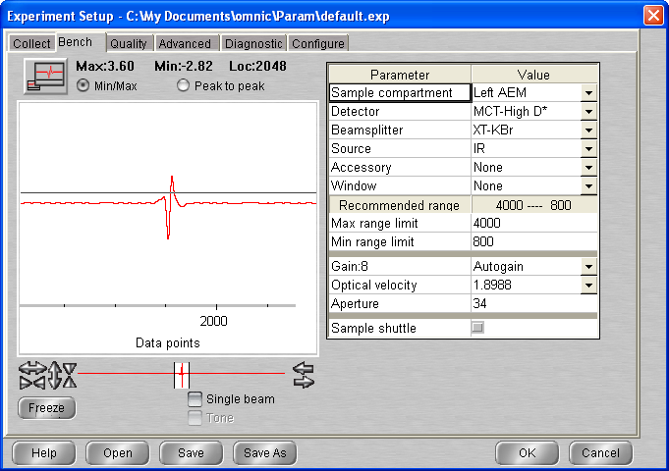

## Background scan(s) #1

**16:00 BG20211007_01**

512 scans res = 1 cm-1 signal = 3.62  
 p = 2.0 * 10-9 mbar T = 19.6

16 :21 Head rotated

Ethane line filling procedure

1. Gas cell pumping 0.56 Torr
2. Close gas cell / Open ethane line for pumping (P in gas line increased to 2.1 e-1)
3. Open regulator and then close regulator + ethane line
4. Open ethane bottle and close
5. Open regulator to introduce 1.4 bar
6. Open gas cell chamber
7. Close pump valve
8. Open ethane black valve and fill gas line with ethane using leak valve
9. Open pump valve and for time to pump
10. Close pump valve and fill gas cell w ethane

## Deposition 1: C2H6 @ 20K

16:40 10 min @ 1x10-7 mbar H2O

- Initial Temperature: 19.6K

- Initial pressure: 1.8 * 10-9 mbar

- Initial gas cell pressure: 8.30 Torr

- Deposition pressure: 1 * 10-7

- Laser signal: 323.8 mV

- Deposition time: 10 min

- pressure after deposition 2.0 e-9

- final gas cell pressure = 8.17 Torr

16:51 Head rotated

**16:55 C2H6_ASW_2021_10_07_0001**

512 scans 1 cm-1 res signal 3.70  
p = 1.7 x 10-9 mbar T = 19.6K

17 :10 Head rotated

## Deposition 2: H2O @ 20K

17:15 20 min @ 1x10-7 mbar H2O

- Initial Temperature: 19.6K

- Initial pressure: 1.6 * 10-9 mbar

- Initial gas cell pressure: 8.38 Torr

- Deposition pressure: 1 * 10-7

- Laser signal: 325.9 mV

- Deposition time: 20 min

- pressure after deposition 1.3 e-8

- final gas cell pressure = 7.30 Torr

17:34 Head rotated / Gas cell pumped

**17:40 C2H6_ASW_2021_10_07_0002**

512 scans 1 cm-1 res signal 3.73  
p = 5.5 x 10-9 mbar T = 19.7K

17 :56 Head rotated

## Deposition 3: C2H6 @ 20K

18:05 10 min @ 1x10-7 mbar H2O

- Initial Temperature: 19.7K

- Initial pressure: 2.5 * 10-9 mbar

- Initial gas cell pressure: 9.14 Torr

- Deposition pressure: 1 * 10-7

- Laser signal: 323.6 mV

- Deposition time: 10 min

- pressure after deposition 2.0 e-9

- final gas cell pressure = 9.01 Torr

18:15 Head rotated

**18:20 C2H6_ASW_2021_10_07_0003**

512 scans 1 cm-1 res signal 3.73  
p = 1.9 x 10-9 mbar T = 19.7K

**18:35 C2H6_ASW_2021_10_07_0004**

512 scans 1 cm-1 res signal 3.68  
p = 1.7 x 10-9 mbar T = 19.7K

**19:10 C2H6_ASW_2021_10_07_0005**

512 scans 1 cm-1 res signal 3.67  
p = 1.5 x 10-9 mbar T = 19.7K

08/10/2021

09 :52 Laser Off

09 :53 MCT Detector cooled

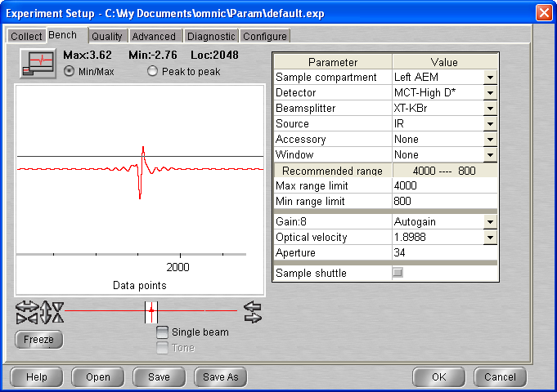

**10:15 C2H6_ASW_2021_10_07_0006**

512 scans 1 cm-1 res signal 3.81  
p = 6.1 x 10-10 mbar T = 19.5K

Macro 2 scans

**11:00 C2H6_ASW_2021_10_07_0009**

512 scans 1 cm-1 res signal 3.90  
p = 6.2 x 10-10 mbar T = 19.5K

## Annealing to 25 K

**11:15 C2H6_ASW_2021_10_07_0010**

512 scans 1 cm-1 res signal 3.91  
p = 6.1 x 10-10 mbar T = 19.5K

Macro 3 scans

**12:15 C2H6_ASW_2021_10_07_0014**

512 scans 1 cm-1 res signal 3.88  
p = 1.3 x 10-9 mbar T = 25K

## Annealing to 30 K

**12:30 C2H6_ASW_2021_10_07_0015**

512 scans 1 cm-1 res signal 3.87  
p = 1.1 x 10-9 mbar T = 25K

**12:45 C2H6_ASW_2021_10_07_0016**

512 scans 1 cm-1 res signal 3.87  
p = 1.1 x 10-9 mbar T = 30K

13 :15 Macro 4 scans

**14:15 C2H6_ASW_2021_10_07_0021**

512 scans 1 cm-1 res signal 3.83  
p = 7.5 x 10-10 mbar T = 30K

**14:30 C2H6_ASW_2021_10_07_0022**

512 scans 1 cm-1 res signal 3.83  
p = 7.5 x 10-10 mbar T = 30K

## Annealing to 40 K

**14:45 C2H6_ASW_2021_10_07_0023**

512 scans 1 cm-1 res signal 3.84  
p = 7.5 x 10-10 mbar T = 30K

Macro 4 scans

## Annealing to 50 K

**16:00 C2H6_ASW_2021_10_07_0028**

512 scans 1 cm-1 res signal 3.84  
p = 8.0 x 10-10 mbar T = 40K

16 :15 Macro 3 scan

**17:00 C2H6_ASW_2021_10_07_0032**

512 scans 1 cm-1 res signal 3.84  
p = 1 x 10-9 mbar T = 50K

## Annealing to 60 K

**17:15 C2H6_ASW_2021_10_07_0033**

512 scans 1 cm-1 res signal 3.84  
p = 9.7 x 10-10 mbar T = 50K

**17:30 C2H6_ASW_2021_10_07_0034**

512 scans 1 cm-1 res signal 3.84  
p = 3.9 x 10-8 mbar T = 59.8K

**17:45 C2H6_ASW_2021_10_07_0035**

512 scans 1 cm-1 res signal 3.84  
p = 4.1 x 10-8 mbar T = 60K

18 :02 MCT Detector cooled

**18:10 C2H6_ASW_2021_10_07_0036**

512 scans 1 cm-1 res signal 3.75  
p = 3.9 x 10-8 mbar T = 60K

18 :24 Macro 60 scans end 08 :08 AM (09/10/2021) – up to scan 96

09/10/2021

13 :03 T = 60 p = 2.15 * 10-8 mbar

13 :20 MCT Detector cooled

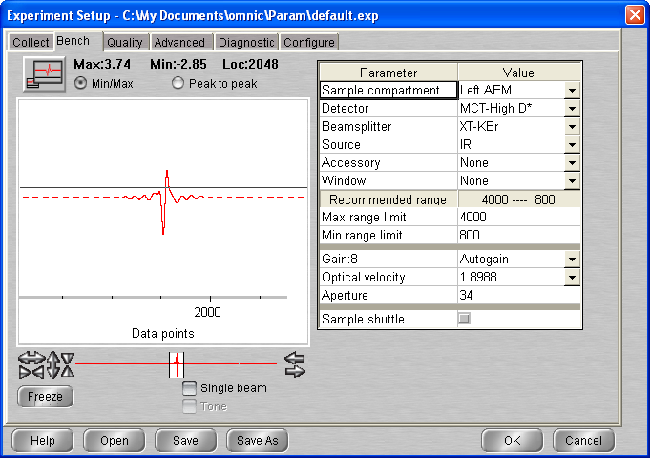

**13:30 C2H6_ASW_2021_10_07_0097**

512 scans 1 cm-1 res signal 3.76  
p = 2.1 x 10-8 mbar T = 60K

**13:45 C2H6_ASW_2021_10_07_0098**

512 scans 1 cm-1 res signal 3.84  
p = 2.1 x 10-8 mbar T = 60K

## Annealing to 65 K

**14:00 C2H6_ASW_2021_10_07_0099**

512 scans 1 cm-1 res signal 3.93  
p = 2.1 x 10-8 mbar T = 60K

**14:15 C2H6_ASW_2021_10_07_0100**

512 scans 1 cm-1 res signal 3.93  
p = 5.3 x 10-7 mbar T = 65K

14 :30 Macro 4 scans

**15:30 C2H6_ASW_2021_10_07_0105**

512 scans 1 cm-1 res signal 3.92  
p = 7.3 x 10-8 mbar T = 65K

## Annealing to 90 K

**15:45 C2H6_ASW_2021_10_07_0106**

512 scans 1 cm-1 res signal 3.91  
p = 6.1 x 10-8 mbar T = 65K

16 :00 Macro 3 scans

**16:45 C2H6_ASW_2021_10_07_0110**

512 scans 1 cm-1 res signal 3.88  
p = 2.9 x 10-9 mbar T = 90K

## Annealing to 120 K

**17:00 C2H6_ASW_2021_10_07_0111**

512 scans 1 cm-1 res signal 3.88  
p = 2.3 x 10-9 mbar T = 90K

17 :15 Macro 2 scans

**17:45 C2H6_ASW_2021_10_07_0114**

512 scans 1 cm-1 res signal 3.88  
p = 4.6 x 10-9 mbar T = 120K

## Annealing to 135 K

**18:00 C2H6_ASW_2021_10_07_0115**

512 scans 1 cm-1 res signal 3.87  
p = 3.6 x 10-9 mbar T = 120K

**18:15 C2H6_ASW_2021_10_07_0116**

512 scans 1 cm-1 res signal 3.87  
p = 6 x 10-8 mbar T = 134.8K

18 :31 MCT Detector cooled

**18:40 C2H6_ASW_2021_10_07_0117**

512 scans 1 cm-1 res signal 3.82  
p = 1.1 x 10-7 mbar T = 135.2K

18 :55 Macro 65 scans (up to scan 182)

10/10/2021

11:36 MCT Detector cooled

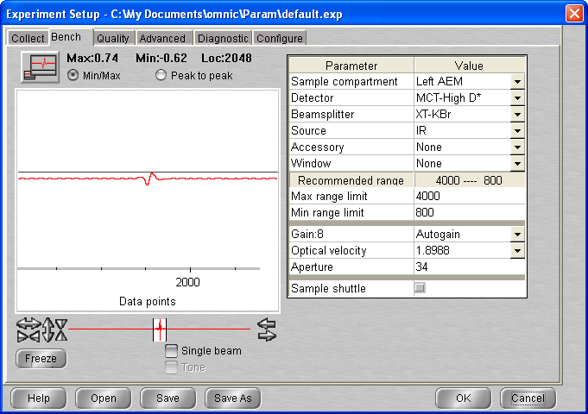

Not good signal plus scan light on spectro blinking (quicker than usual)

11: 48 COMPUTER TURNED ON AND OFF

Problem solved

**12:00 C2H6_ASW_2021_10_07_0183**

512 scans 1 cm-1 res signal 3.76  
p = 1.0 x 10-8 mbar T = 135.0K

12 :15 Macro 10 scans

**14:45 C2H6_ASW_2021_10_07_0194**

512 scans 1 cm-1 res signal 3.80  
p = 9.4 x 10-9 mbar T = 135.0K

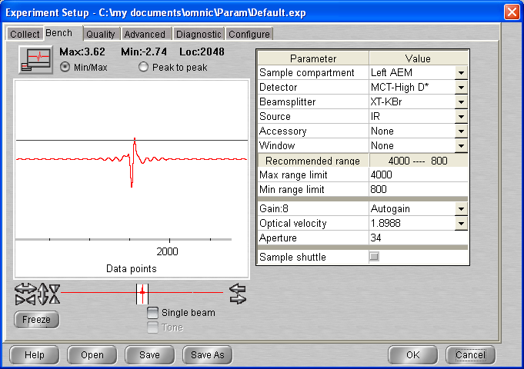

## Annealing to 140 K

**15:00 C2H6_ASW_2021_10_07_0195**

512 scans 1 cm-1 res signal 3.80  
p = 9.4 x 10-9 mbar T = 135K

15 :15 Macro 3 scans

## Annealing to 150 K

**16:00 C2H6_ASW_2021_10_07_0199**

512 scans 1 cm-1 res signal 3.77  
p = 3.4 x 10-8 mbar T = 140K

16 :15 Macro 10 scans exit at loop 9 up to scan

**18:20 C2H6_ASW_2021_10_07_0209**

512 scans 1 cm-1 res signal 3.71  
p = 4.2 x 10-9 mbar T = 150K

18 :40 cryo off heater man 0

# Monday 11th Oct 2021 (VD) – ASW:C2H6 10:1 Mixture

10:18 T = 277.3K P = 1.2 e-8

10:45 Cryo ON

10:45 Laser On

11:46 MCT Detector cooled

11:47 T = 94.8 P = 2.1 e-9 mbar

13:11 T = 19.5 K P = 1.3 * 10-9 mbar

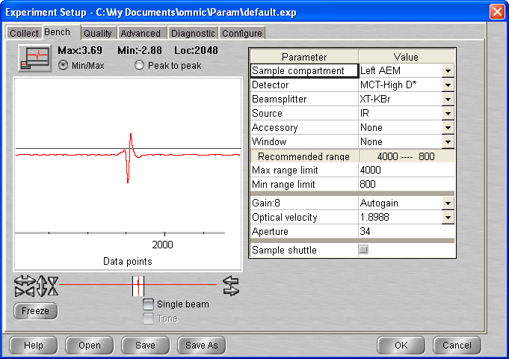

## Background scan(s) #1

**13:15 BG20211011_01**

512 scans res = 1 cm-1 signal = 3.71  
 p = 1.3 * 10-9 mbar T = 19.5

## Deposition : H2O:C2H6 (10:1) @ 20K

15:35 20 min @ 1x10-7 mbar H2O

- Initial Temperature: 19.5K

- Initial pressure: 1.1 * 10-9 mbar

- Initial gas cell pressure: 1.016 Torr

Procedure:

1. Gas cell pumping 0.55 Torr
2. Close gas cell / Open ethane line for pumping (P in gas line increased to 2.1 e-1)
3. Open regulator and then close regulator + ethane line
4. Open ethane bottle and close
5. Open regulator to introduce 1.4 bar
6. Open gas cell chamber
7. Close pump valve
8. Open ethane black valve and fill gas line with ethane using leak valve
9. Open pump valve and for time to pump
10. Close pump valve and fill gas cell w ethane 0.055 + **0.501 = 0.556**
11. Open water valve 0.556 + **0.499 = 1.055**
12. Pump valve open until we reached **0.152 Torr**
13. **Water valve open up to 1.052**
14. **Gas cell chamber valve closed**

- Deposition pressure: 1 * 10-7

- Laser signal: 328.2 mV

- Deposition time: 20 min

- pressure after deposition 7.3 e-9

- final gas cell pressure = 0.920 Torr

15:55 Head rotated Laser off

**16:00 C2H6_ASW_2021_10_11_0001**

512 scans 1 cm-1 res signal 3.38  
p = 3.5 x 10-9 mbar T = 19.6K

**16:15 C2H6_ASW_2021_10_11_0002**

512 scans 1 cm-1 res signal 3.52  
p = 1.8 x 10-9 mbar T = 19.5K

**16:30 C2H6_ASW_2021_10_11_0003**

512 scans 1 cm-1 res signal 3.52  
p = 1.4 x 10-9 mbar T = 19.5K

**17:00 C2H6_ASW_2021_10_11_0004**

512 scans 1 cm-1 res signal 3.52  
p = 1.1 x 10-9 mbar T = 19.5K

## Annealing to 30 K

**17:15 C2H6_ASW_2021_10_11_0005**

512 scans 1 cm-1 res signal 3.52  
p = 1.1 x 10-9 mbar T = 19.5K

**17:30 C2H6_ASW_2021_10_11_0006**

512 scans 1 cm-1 res signal 3.52  
p = 1.4 x 10-9 mbar T = 29.9K

**17:45 C2H6_ASW_2021_10_11_0007**

512 scans 1 cm-1 res signal 3.52  
p = 1.2 x 10-9 mbar T = 29.9K

## Annealing to 40 K

**18:00 C2H6_ASW_2021_10_11_0008**

512 scans 1 cm-1 res signal 3.50  
p = 1.2 x 10-9 mbar T = 30K

18 :15 Macro 20 scans exit at loop 17 up to scan 25

22:16 MCT Detector cooled

**22:20 C2H6_ASW_2021_10_11_0026**

512 scans 1 cm-1 res signal 3.50  
p = 9.2 x 10-10 mbar T = 40K

22 :40 Macro 65 scans exit at loop 57 up to scan 83

12/10/2021

12 :00 MCT Detector cooled

**12:15 C2H6_ASW_2021_10_11_0084**

512 scans 1 cm-1 res signal 3.51  
p = 6.7 x 10-10 mbar T = 40K

12 :30 Macro 10 scans exit at loop 6

## Annealing to 50 K

**14:00 C2H6_ASW_2021_10_11_0091**

512 scans 1 cm-1 res signal 3.49  
p = 6.8 x 10-10 mbar T = 40K

Macro 15 scans exit at loop 13

## Annealing to 60 K

**17:20 C2H6_ASW_2021_10_11_0105**

512 scans 1 cm-1 res signal 3.49  
p = 7.6 x 10-10 mbar T = 50K

**17:35 C2H6_ASW_2021_10_11_0106**

512 scans 1 cm-1 res signal 3.49  
p = 1 x 10-9 mbar T = 50K

17 :54 T = 60 P = 8 e-10

17 :55 Macro 65 scans up to scan 171

13/10/2021

10 :46 MCT Detector cooled (not full – not enough lN2)

**10:50 C2H6_ASW_2021_10_11_0172**

512 scans 1 cm-1 res signal 3.30  
p = 6 x 10-10 mbar T = 60K

**11:15 C2H6_ASW_2021_10_11_0173**

512 scans 1 cm-1 res signal 3.56  
p = 6.2 x 10-10 mbar T = 60K

**11:30 C2H6_ASW_2021_10_11_0174**

512 scans 1 cm-1 res signal 3.56  
p = 6.0 x 10-10 mbar T = 60K

**11:50 C2H6_ASW_2021_10_11_0175**

512 scans 1 cm-1 res signal 3.49  
p = 6.0 x 10-10 mbar T = 60K

## Annealing to 65 K

**11:50 C2H6_ASW_2021_10_11_0176**

512 scans 1 cm-1 res signal 3.57  
p = 6.0 x 10-10 mbar T = 60K

12 :20 Macro 10 scans

## Annealing to 90 K

**11:50 C2H6_ASW_2021_10_11_0187**

512 scans 1 cm-1 res signal 3.53  
p = 7.5 x 10-10 mbar T = 65K

15 :00 Macro 4 scans

**16:00 C2H6_ASW_2021_10_11_0192**

512 scans 1 cm-1 res signal 3.53  
p = 1.4 x 10-9 mbar T = 90K

## Annealing to 120 K

**16:20 C2H6_ASW_2021_10_11_0193**

512 scans 1 cm-1 res signal 3.52  
p = 1.3 x 10-9 mbar T = 90K

16 :35 Macro 3 scans

**17:20 C2H6_ASW_2021_10_11_0197**

512 scans 1 cm-1 res signal 3.53  
p = 3.4 x 10-9 mbar T = 120K

## Annealing to 135 K

**17:35 C2H6_ASW_2021_10_11_0198**

512 scans 1 cm-1 res signal 3.52  
p = 1.3 x 10-9 mbar T = 120K

**17:50 C2H6_ASW_2021_10_11_0199**

512 scans 1 cm-1 res signal 3.52  
p = 8 x 10-8 mbar T = 134.8K

18 :05 MCT Detector cooled

**18:15 C2H6_ASW_2021_10_11_0200**

512 scans 1 cm-1 res signal 3.52  
p = 9 x 10-8 mbar T = 135K

18 :30 Macro 65 scan up to 10 :11 scan 265

14 /10/2021

10 :49 MCT Detector cooled

**11:00 C2H6_ASW_2021_10_11_0266**

512 scans 1 cm-1 res signal 3.65  
p = 9.9 x 10-9 mbar T = 135K

11 :15 Macro 20 scans

**16:00 C2H6_ASW_2021_10_11_0287**

512 scans 1 cm-1 res signal 3.63  
p = 9.9 x 10-9 mbar T = 135K

**16:15 C2H6_ASW_2021_10_11_0288**

512 scans 1 cm-1 res signal 3.63  
p = 9.9 x 10-9 mbar T = 135K

**16:30 C2H6_ASW_2021_10_11_0289**

512 scans 1 cm-1 res signal 3.62  
p = 9.8 x 10-9 mbar T = 135K

*

**17:00 C2H6_ASW_2021_10_11_0290**

512 scans 1 cm-1 res signal 3.62  
p = 9.7 x 10-9 mbar T = 135K

(lots of timeout !! )

17 :25 Macro 20 scans

15/10/2021

10 :50 MCT Detector cooled

**11:00 C2H6_ASW_2021_10_11_0311**

512 scans 1 cm-1 res signal 3.38  
p = 7.2 x 10-9 mbar T = 135K

**11:15 C2H6_ASW_2021_10_11_0312**

512 scans 1 cm-1 res signal 3.38  
p = 7.2 x 10-9 mbar T = 135K

**11:30 C2H6_ASW_2021_10_11_0313**

512 scans 1 cm-1 res signal 3.66  
p = 7.2 x 10-9 mbar T = 135K

**11:45 C2H6_ASW_2021_10_11_0313**

512 scans 1 cm-1 res signal 3.38  
p = 7.2 x 10-9 mbar T = 135K

12 :00 Macro 4 scans

13 :00 Macro 4 scans

## Annealing to 140 K

**14:15 C2H6_ASW_2021_10_11_0323**

512 scans 1 cm-1 res signal 3.52  
p = 7.1 x 10-9 mbar T = 135K

14 :30 Macro 4 scans

**15:30 C2H6_ASW_2021_10_11_0328**

512 scans 1 cm-1 res signal 3.59  
p = 2.8 x 10-8 mbar T = 140K

## Annealing to 150 K

**15:45 C2H6_ASW_2021_10_11_0329**

512 scans 1 cm-1 res signal 3.59  
p = 7.1 x 10-9 mbar T = 135K

16 :00 Macro 20 scans exit at loop 15 up to scan 344

19:40 cryo off heater off

# Monday 18th Oct 2021 (VD) –

10:18 T = 278K P = 5.6 e-9

10:22 Cryo ON

10:22 Laser On

11:10 MCT Detector cooled

11:13 T = 137.3 P = 1.5 e-9 mbar

12:02 T = 19.7 P = 8.7 * 10-10

14:59 T = 19.5 P= 8 e-10 mbar

15:00 T set up to 100K gas cell pumping

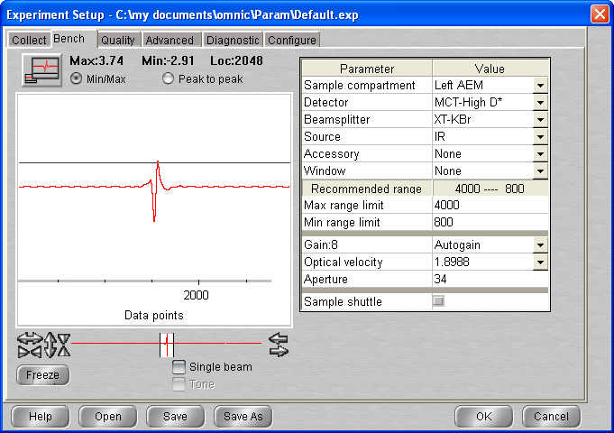

No background taken CO2 level too high …

19/10/2021

10:55 T = 277K P = 5.1 e-9

10:56 Cryo ON

10:56 Laser On

11:30 MCT Detector cooled

13:10 T = 19.5K P = 7.4 * 10-10

T set-up 100K

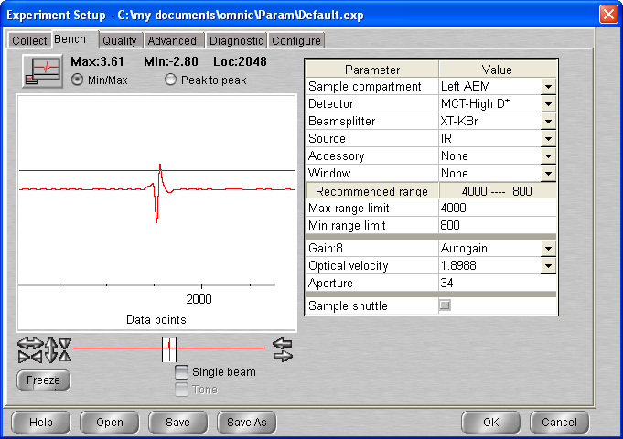

## Background scan(s) #1

**13:45 BG20211018_01**

512 scans res = 1 cm-1 signal = 3.69  
 p = 2.3 * 10-9 mbar T = 100K

14 :10 Head rotated

## Deposition 1: H2O @ 100K 🡪 np ASW

14:15 20 min @ 1x10-7 mbar H2O

- Initial Temperature: 100K

- Initial pressure: 1.5 * 10-9 mbar

- Initial gas cell pressure: (0.55 initial) 7.25 Torr

- Deposition pressure: 1 * 10-7

- Laser signal: 327.8 mV

- Deposition time: 20 min

- pressure after deposition 8.3 e-9

- final gas cell pressure = 6.46 Torr

14:35 Head rotated / Gas cell pumped

**14:45 C2H6_ASW_2021_10_18_0001**

512 scans 1 cm-1 res signal 3.77  
p = 2.7 x 10-9 mbar T = 100K

15 :02 Heater set to man 0

15 :21 T = 19.5K P = 9.3 * 10-10 mbar

**15:30 C2H6_ASW_2021_10_18_0002**

512 scans 1 cm-1 res signal 3.75  
p = 9.0 x 10-9 mbar T = 19.4K

**15:52 C2H6_ASW_2021_10_18_0003**

512 scans 1 cm-1 res signal 3.75  
p = 8.0 x 10-9 mbar T = 19.3K

16:10 Head rotated

## Deposition 2: C2H6 @ 20K

16:25 10 min @ 1x10-7 mbar C2H6

- Initial Temperature: 19.2K

- Initial pressure: 8 * 10-10 mbar

- Initial gas cell pressure: (0.56 initial) 7.81 Torr

- Deposition pressure: 1 * 10-7

- Laser signal: 326.5 mV

- Deposition time: 10 min

- pressure after deposition 1.5 e-9

- final gas cell pressure = 7.51 Torr

16:36 Head rotated / Laser off

**16:40 C2H6_ASW_2021_10_18_0004**

512 scans 1 cm-1 res signal 3.86  
p = 1.0 x 10-9 mbar T = 19.2K

**17:00 C2H6_ASW_2021_10_18_0005**

512 scans 1 cm-1 res signal 3.86  
p = 7.8 x 10-10 mbar T = 19.1K

## Annealing to 30 K

**17:15 C2H6_ASW_2021_10_18_0006**

512 scans 1 cm-1 res signal 3.87  
p = 7.7 x 10-10 mbar T = 19.1K

(pressure remain high (e-7) during whole scan )

17:30 Macro 4 scans

**18:30 C2H6_ASW_2021_10_18_0011**

512 scans 1 cm-1 res signal 3.82  
p = 7.4 x 10-8 mbar T = 30K

## Annealing to 35 K

**18:45 C2H6_ASW_2021_10_18_0012**

512 scans 1 cm-1 res signal 3.87  
p = 5.2 x 10-8 mbar T = 30K

19 :00 Macro 4 scans

**20:00 C2H6_ASW_2021_10_18_0017**

512 scans 1 cm-1 res signal 3.87  
p = 5.2 x 10-8 mbar T = 35K

20 :17 MCT Detector refilled

**20:20 C2H6_ASW_2021_10_18_0018**

512 scans 1 cm-1 res signal 3.75  
p = 2.4 x 10-8 mbar T = 35K

20 :35 Macro 65 scans exit at loop 60 up to scan 78

20/10

10:47 MCT Detector cooled

**11:00 C2H6_ASW_2021_10_18_0079**

512 scans 1 cm-1 res signal 3.74  
p = 1.2 x 10-9 mbar T = 35K

## Annealing to 40 K

**11:15 C2H6_ASW_2021_10_18_0080**

512 scans 1 cm-1 res signal 3.73  
p = 5.2 x 10-8 mbar T = 35K

11 :30 Macro 6 scans

**13:00 C2H6_ASW_2021_10_18_0087**

512 scans 1 cm-1 res signal 3.73  
p = 3.6 x 10-9 mbar T = 40K

13 :15 Macro 6 scans

## Annealing to 50 K

**14:45 C2H6_ASW_2021_10_18_0094**

512 scans 1 cm-1 res signal 3.73  
p = 2 x 10-9 mbar T = 45K

15 :00 Macro 6 scans

## Annealing to 60 K

**16:30 C2H6_ASW_2021_10_18_0101**

512 scans 1 cm-1 res signal 3.70  
p = 1.3 x 10-9 mbar T = 50K

**16:45 C2H6_ASW_2021_10_18_0102**

512 scans 1 cm-1 res signal 3.70  
p = 3.8 x 10-8 mbar T = 60K

**17:00 C2H6_ASW_2021_10_18_0103**

512 scans 1 cm-1 res signal 3.70  
p = 3.6 x 10-8 mbar T = 60K

**17:15 C2H6_ASW_2021_10_18_0104**

512 scans 1 cm-1 res signal 3.70  
p = 3.5 x 10-8 mbar T = 60K

## Annealing to 65 K

**17:30 C2H6_ASW_2021_10_18_0105**

512 scans 1 cm-1 res signal 3.70  
p = 3.3 x 10-9 mbar T = 60K

**17:45 C2H6_ASW_2021_10_18_0106**

512 scans 1 cm-1 res signal 3.68  
p = 1.8 x 10-7 mbar T = 65K

**18:00 C2H6_ASW_2021_10_18_0107**

512 scans 1 cm-1 res signal 3.68  
p = 2.7 x 10-8 mbar T = 65K

## Annealing to 135 K

**18:15 C2H6_ASW_2021_10_18_0108**

512 scans 1 cm-1 res signal 3.68  
p = 2.4 x 10-8 mbar T = 65K

**18:30 C2H6_ASW_2021_10_18_0109**

512 scans 1 cm-1 res signal 3.68  
p = 4 x 10-8 mbar T = 135K

18 :46 MCT Detector cooled

18 :50 Macro 65 scans up to 9 :41 (scan 174)

10:52 MCT Detector cooled

**11:00 C2H6_ASW_2021_10_18_0175**

512 scans 1 cm-1 res signal 3.71  
p = 8.6 x 10-9 mbar T = 135K

**11:15 C2H6_ASW_2021_10_18_0176**

512 scans 1 cm-1 res signal 3.71  
p = 8.4 x 10-9 mbar T = 135K

**11:30 C2H6_ASW_2021_10_18_0177**

512 scans 1 cm-1 res signal 3.71  
p = 8.3 x 10-9 mbar T = 135K

11 :45 Macro 4 scan

## Annealing to 140 K

**12:45 C2H6_ASW_2021_10_18_0182**

512 scans 1 cm-1 res signal 3.68  
p = 7.8 x 10-9 mbar T = 135K

13 :00 Macro 4 scans

## Annealing to 150 K

**14:00 C2H6_ASW_2021_10_18_0187**

512 scans 1 cm-1 res signal 3.65  
p = 2.7 x 10-8 mbar T = 140K

14 :15 Macro 20 scans up to scan 207

# Friday 22th Oct 2021 (VD) – ASW:C2H6 10:1 Mixture deposited at 100K

10:07 T = 274.7K P = 7 e-9

10:08 Cryo ON

10:08 Laser On

11:05 MCT Detector cooled

11:07 T = 99.6 P = 1.5 * 10-9

Procedure:

1. Gas cell pumping 0.55 Torr
2. Close gas cell / Open ethane line for pumping (P in gas line increased to 2.1 e-1)
3. Make sure water needle valve pumped and close (before ethane intro)
4. Open regulator and then close regulator + ethane line
5. Open ethane bottle and close
6. Open regulator to introduce 1.4 bar
7. Open gas cell chamber
8. Close pump valve
9. Open ethane black valve and fill gas line with ethane using leak valve
10. Open pump valve and for time to pump
11. Close pump valve and fill gas cell w ethane 0.057 + **0.499 = 0.556**
12. Open water valve 0.556 + **0.500 = 1.056**
13. Pump valve open until we reached **0.157 Torr**
14. **Water valve open up to 1.060**
15. **Gas cell chamber valve closed**

**11:30 T = 19.5 P = 9.2 * 10-10**

**T set-up to 100K**

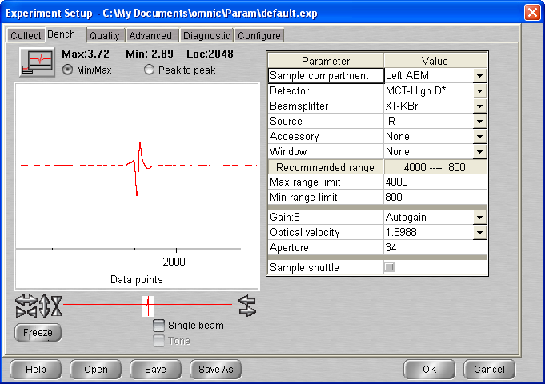

## Background scan(s) #1

**12:00 BG20211022_01**

512 scans res = 1 cm-1 signal = 3.71  
 p = 2.4 * 10-9 mbar T = 100K

12 :15 Head rotated

## Deposition: H2O:C2H6 10:1 @ 100K

12:20 20 min @ 1x10-7 mbar H2O

- Initial Temperature: 100K

- Initial pressure: 1.7 * 10-9 mbar

- Initial gas cell pressure: 1.002 Torr

- Deposition pressure: 1 * 10-7

- Laser signal: 328.3 mV

- Deposition time: 20 min

- pressure after deposition 3.8 e-9

- final gas cell pressure = 0.990 Torr

12:40 Head rotated / Gas cell pumped

**12:40 C2H6_ASW_2021_10_22_0001**

512 scans 1 cm-1 res signal 3.69  
p = 2.5 x 10-9 mbar T = 100K

12 :55 Macro 6 scans

## Annealing to 135 K

**14:20 C2H6_ASW_2021_10_22_0008**

512 scans 1 cm-1 res signal 3.66  
p = 1.1 x 10-9 mbar T = 100K

14 :35 Macro 30 scans exit at loop 12

## Annealing to 140 K

**17:30 C2H6_ASW_2021_10_22_0021**

512 scans 1 cm-1 res signal 3.65  
p = 1.5 x 10-8 mbar T = 135K

**17:45 C2H6_ASW_2021_10_22_0022**

512 scans 1 cm-1 res signal 3.65  
p = 5.6 x 10-8 mbar T = 140K

**18:00 C2H6_ASW_2021_10_22_0023**

512 scans 1 cm-1 res signal 3.65  
p = 4.8 x 10-8 mbar T = 140K

**18:15 C2H6_ASW_2021_10_22_0024**

512 scans 1 cm-1 res signal 3.65  
p = 3.7 x 10-8 mbar T = 140K

Heater off / cryo off

# Sunday 24th Oct 2021 (VD) –

11:22 T = 278.1K P = 4.2 * 10 e-9

11:23 Cryo ON

11:23 Laser On

11:48 MCT Detector cooled

12:20 T = 112 p = 1.1 * 10-9

12:50 T = 19.7 P = 6.7 * 10-10

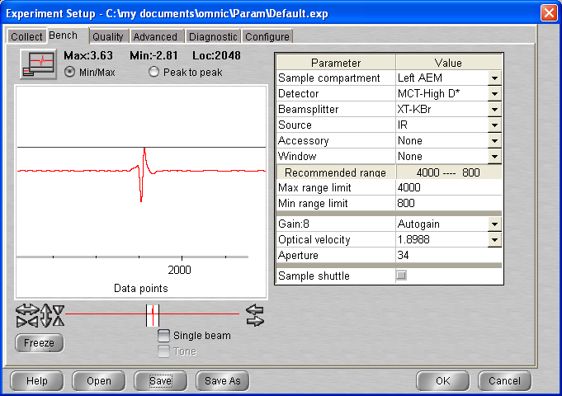

## Background scan(s) #1

**13:05 BG20211024_01**

512 scans res = 1 cm-1 signal = 3.69  
 p = 6.3 * 10-10 mbar T = 19.6K

13 :20 Head rotated

## Deposition 1: H2O @ 20K

13:30 20 min @ 1x10-7 mbar H2O

- Initial Temperature: 19.6K

- Initial pressure: 6.3 * 10-9 mbar

- Initial gas cell pressure: (0.55 initial) 7.45 Torr

- Deposition pressure: 1 * 10-7

- Laser signal: 327.8 mV

- Deposition time: 20 min

- pressure after deposition 7 * e-9

- final gas cell pressure = 6.36 Torr

13:50 Head rotated / Gas cell pumped

**13:55 C2H6_ASW_2021_10_24_0001**

512 scans 1 cm-1 res signal 3.69  
p = 4 x 10-9 mbar T = 19.6K

**14:10 C2H6_ASW_2021_10_24_0002**

512 scans 1 cm-1 res signal 3.69  
p = 1.4 x 10-9 mbar T = 19.6K

## Annealing to 100 K

**14:30 C2H6_ASW_2021_10_24_0003**

512 scans 1 cm-1 res signal 3.68  
p = 1.0 x 10-10 mbar T = 19.1K

**14:45 C2H6_ASW_2021_10_24_0004**

512 scans 1 cm-1 res signal 3.68  
p = 2.6 x 10-9 mbar T = 99.4K

**15:00 C2H6_ASW_2021_10_24_0005**

512 scans 1 cm-1 res signal 3.68  
p = 1.8 x 10-9 mbar T = 99.9K

## Cooling to 20 K

15:15 Heater man 0

**15:15 C2H6_ASW_2021_10_24_0006**

512 scans 1 cm-1 res signal 3.66  
p = 1.5 x 10-9 mbar T = 100K

**15:30 C2H6_ASW_2021_10_24_0007**

512 scans 1 cm-1 res signal 3.64  
p = 9.2 x 10-10 mbar T = 35K

**15:45 C2H6_ASW_2021_10_24_0008**

512 scans 1 cm-1 res signal 3.64  
p = 6.7 x 10-10 mbar T = 19.5K

16 :00 Macro 50 scan

25/10/2021

10 :15 MCT Detector cooled

**10:30 C2H6_ASW_2021_10_24_0059**

512 scans 1 cm-1 res signal 3.35  
p = 5 x 10-10 mbar T = 19.2K

**10:45 C2H6_ASW_2021_10_24_0060**

512 scans 1 cm-1 res signal 3.63  
p = 5 x 10-10 mbar T = 19.2K

**11:00 C2H6_ASW_2021_10_24_0061**

512 scans 1 cm-1 res signal 3.66  
p = 5 x 10-10 mbar T = 19.2K

11 :20 Head rotated

## Deposition 2: C2H6 @ 20K

11:30 10 min @ 1x10-7 mbar C2H6

- Initial Temperature: 19.1K

- Initial pressure: 5 * 10-10 mbar

- Initial gas cell pressure: (0.55 initial) 8.07 Torr

- Deposition pressure: 1 * 10-7

- Laser signal: 324.7 mV

- Deposition time: 10 min

- pressure after deposition 1 e-9

- final gas cell pressure = 7.75 Torr

11:41 Head rotated / Laser off

**11:45 C2H6_ASW_2021_10_24_0062**

512 scans 1 cm-1 res signal 3.74  
p = 7 x 10-10 mbar T = 19.1K

Macro 4 scans

## Annealing to 30 K

**13:15 C2H6_ASW_2021_10_24_0067**

512 scans 1 cm-1 res signal 3.73  
p = 5 x 10-10 mbar T = 19.1K

Time outs …

13 :35 Macro 3 scans

**14:35 C2H6_ASW_2021_10_24_0071**

512 scans 1 cm-1 res signal 3.71  
p = 2.1 x 10-7 mbar T = 30K

**14:50 C2H6_ASW_2021_10_24_0072**

512 scans 1 cm-1 res signal 3.71  
p = 1.7 x 10-7 mbar T = 30K

## Annealing to 40 K

**15:15 C2H6_ASW_2021_10_24_0073**

512 scans 1 cm-1 res signal 3.66  
p = 1.1 x 10-7 mbar T = 30K

15 :30 Macro 3 scans

**16:20 C2H6_ASW_2021_10_24_0077**

512 scans 1 cm-1 res signal 3.66  
p = 8.5 x 10-9 mbar T = 40K

## Annealing to 50 K

**16:40 C2H6_ASW_2021_10_24_0078**

512 scans 1 cm-1 res signal 3.66  
p = 6.0 x 10-9 mbar T = 40K

Macro 3 scans (probelem with number of scan !!)

**18:00 C2H6_ASW_2021_10_24_0082**

512 scans 1 cm-1 res signal 3.66  
p = 3.2 x 10-9 mbar T = 50K

## Annealing to 60 K

**18:15 C2H6_ASW_2021_10_24_0083**

512 scans 1 cm-1 res signal 3.65  
p = 2.6 x 10-9 mbar T = 50K

Macro 2 scans

**19:00 C2H6_ASW_2021_10_24_0086**

512 scans 1 cm-1 res signal 3.65  
p = 6 x 10-9 mbar T = 60K

**19:15 C2H6_ASW_2021_10_24_0087**

512 scans 1 cm-1 res signal 3.63  
p = 5.8 x 10-9 mbar T = 60K

Macro 10 scans

**22:50 C2H6_ASW_2021_10_24_0098**

512 scans 1 cm-1 res signal 3.63  
p = 5.8 x 10-9 mbar T = 60K

## Annealing to 135 K

**23:10 C2H6_ASW_2021_10_24_0099**

512 scans 1 cm-1 res signal 3.65  
p = 3.7 x 10-9 mbar T = 60K

**23:23 C2H6_ASW_2021_10_24_0100**

512 scans 1 cm-1 res signal 3.65  
p = 2.7 x 10-8 mbar T = 132.9K

23 :44 MCT Detector cooled

23 :45 Macro 60 scan exit at loop 51

12:40 MCT Detector cooled

**12:45 C2H6_ASW_2021_10_24_0152**

512 scans 1 cm-1 res signal 3.63  
p = 9.4 x 10-9 mbar T = 135K

Macro 20 scans

## Annealing to 140 K

**17:00 C2H6_ASW_2021_10_24_0168**

512 scans 1 cm-1 res signal 3.65  
p = 8.6 x 10-9 mbar T = 135K

Macro 3 scans

## Annealing to 150 K

**18:00 C2H6_ASW_2021_10_24_0172**

512 scans 1 cm-1 res signal 3.65  
p = 8.6 x 10-9 mbar T = 135K

Macro 10 scans

Time outs (rate not accurate)

**22:52 C2H6_ASW_2021_10_24_0183**

512 scans 1 cm-1 res signal 3.65  
p = 2.9 x 10-7 mbar T = 150K

# Thursday 28th Oct 2021 (VD – AD - PAH) ASW:C2H6 mixture 5:1

12:37 Cryo ON yesterday

09:51 MCT Detector cooled

09:52 T = 19.4K P = 5 e-10 mbar

15:26 Laser On

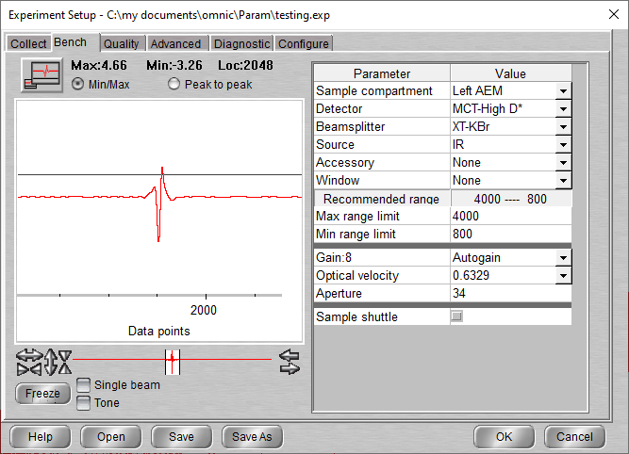

## Background scan(s) #1

**10:21 BG20211028_01**

256 scans res = 1 cm-1 signal = 4.67  
 p = 5.0 * 10-10 mbar T = 19.5

Think About click “Collect background before every sample”

You will need to save it manually

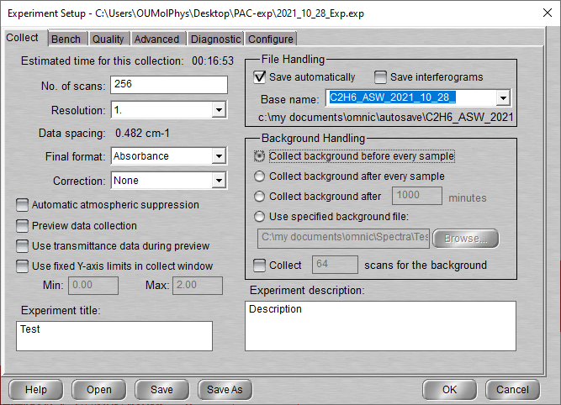

“Use the specified BG file”.

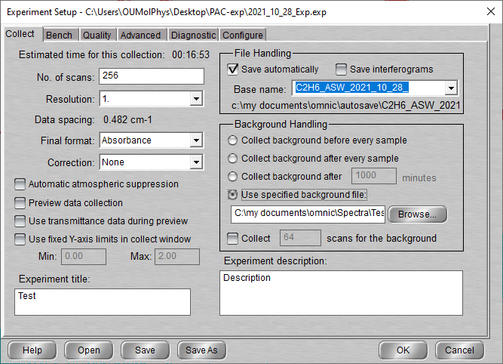

## Deposition: ASW:C2H6 5:1 @ 20K

16:40 20 min @ 1x10-7 mbar H2O:C2H6 (5:1)

- Initial Temperature: 19.5K

- Initial pressure: 5 * 10-10 mbar

Gas cell filling:

Init P (zero offset): 0.055

Ethane intro: 0.555

Water intro: 1.035

Pumped down to: 0.235

Water intro 2: 1.035

Gas cell P (final): 1.000

- Deposition pressure: 1 * 10-7

- Laser signal: 328.2 mV

- Deposition time: 10 min

- final gas cell pressure = 0.880Torr

11:47 Head rotated?Laser turned off

**11:50 C2H6_ASW_2021_10_28_0002**

216 scans 1 cm-1 res signal 4.16  
p = 3.8 x 10-9 mbar T = 19.5K

**13:16 C2H6_ASW_2021_10_28_0003**

216 scans 1 cm-1 res signal 4.16  
p = 6.1 x 10-10 mbar T = 19.5K

## Electron IRRADIATION

Turn surface 90 degree in opposite direction than for deposition (down to 270)

Turn Electron Gun (EG) On

Press Resume (Saved setting)

ALLOW TIME FOR IT TO WARM UP (10 microA)

13:39 Pressure start rising (10 – 11 micro amps)

Irradiation spot (to check)

13:41 P= 1.3 * 10-7 mbar

13:55 P = 3 e-7 T = 19.6K

13:59 electron gun turned off

14:00 Head rotated

**14:00 C2H6_ASW_2021_10_28_0004**

216 scans 1 cm-1 res signal 3.62  
p = 1.1 x 10-7 mbar T = 19.5K

## Warm up to 120K

**14:20 C2H6_ASW_2021_10_28_0005**

216 scans 1 cm-1 res signal 3.62

**14:40 C2H6_ASW_2021_10_28_0006**

216 scans 1 cm-1 res signal 3.62

**15:45 C2H6_ASW_2021_10_28_0007**

216 scans 1 cm-1 res signal 3.62  
p = 7.5 x 10-9 mbar T = 120K

**16:05 C2H6_ASW_2021_10_28_0008**

216 scans 1 cm-1 res signal 3.62  
p = 6.1 x 10-9 mbar T = 120K

## Warm up to 135K

**16:40 C2H6_ASW_2021_10_28_0009**

216 scans 1 cm-1 res signal 3.62

**17:00 C2H6_ASW_2021_10_28_0010**

216 scans 1 cm-1 res signal 3.62

**17:20 C2H6_ASW_2021_10_28_0011**

216 scans 1 cm-1 res signal 3.65

17 :40 MCT Detector cooled

**17:40 C2H6_ASW_2021_10_28_0012**

216 scans 1 cm-1 res signal 3.60

18 :00 Macro 50 scans

29/10/2021

10 :30 Computer was turned off (Macro started when comp turned on at loop 4)

10 :40 Macro exit (loop 4 signal 1.58) up to scan 16

**11 :05 MCT Detector cooled**

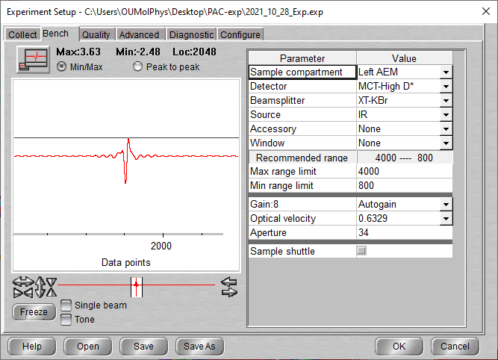

**11:15 C2H6_ASW_2021_10_28_0017**

216 scans 1 cm-1 res signal 3.67  
p = 8.5 x 10-9 mbar T = 135K

11 :35 Macro 10 scans (again, Macro stop when computer go to sleep mode)

14 :45 Heater man 0 / cryo off